UNIVERSITY OF GHANA
COLLEGE OF BASIC AND APPLIED SCIENCES

SAFEVOICE: A TRAUMA-INFORMED, CRYPTOGRAPHICALLY VERIFIED DIGITAL PUBLIC INFRASTRUCTURE FOR CRISIS REPORTING AND CASE MANAGEMENT IN GHANA

BY

SAVIOUR BAAKUM
(10984321)

A THESIS SUBMITTED TO THE DEPARTMENT OF COMPUTER SCIENCE, SCHOOL OF GRADUATE STUDIES, UNIVERSITY OF GHANA, IN PARTIAL FULFILLMENT OF THE REQUIREMENTS FOR THE AWARD OF THE DEGREE OF MASTER OF SCIENCE IN COMPUTER SCIENCE

DEPARTMENT OF COMPUTER SCIENCE
LEGON, ACCRA

SEPTEMBER, 2026

DECLARATION
I, SAVIOUR BAAKUM, hereby declare that this thesis entitled "SafeVoice: A Trauma-Informed, Cryptographically Verified Digital Public Infrastructure for Crisis Reporting and Case Management in Ghana" is the result of my own independent research carried out under the supervision of DR. KOFI SARPONG in the Department of Computer Science, University of Ghana.
This work has not been presented either in whole or in part for the award of any other degree in this university or elsewhere. All citations and secondary materials consulted have been fully acknowledged.
<br><br>
Student:
Name: Saviour Baakum
Signature: \_\_\_\_\_\_\_\_\_\_\_\_\_\_\_\_\_\_\_\_\_\_\_\_\_\_\_
Date: \_\_\_\_\_\_\_\_\_\_\_\_\_\_\_\_\_\_\_\_\_\_\_\_\_\_\_\_\_\_
<br><br>
Supervisor:
I hereby certify that this thesis was prepared under my direct supervision in accordance with the guidelines on supervision of research laid down by the University of Ghana.
Name: Dr. Kofi Sarpong
Signature: \_\_\_\_\_\_\_\_\_\_\_\_\_\_\_\_\_\_\_\_\_\_\_\_\_\_\_
Date: \_\_\_\_\_\_\_\_\_\_\_\_\_\_\_\_\_\_\_\_\_\_\_\_\_\_\_\_\_\_

ABSTRACT
Context: Gender-based violence, domestic abuse, and child maltreatment remain persistent public safety challenges across Ghana. Despite statutory protection mandates established under the Domestic Violence Act, 2007 (Act 732) and the Children's Act, 1998 (Act 560), formal incident reporting faces acute systemic attrition. Victims living in shared residential quarters with their assailants encounter physical retaliation during coercive device searches. Past digital interventions, such as the Ministry of Gender, Children and Social Protection's Boame mobile application (2021), suffered attrition rates exceeding 80% due to mobile app-store download barriers, continuous cellular data costs, and persistent home-screen visual artifacts. Furthermore, evidence collected informally on smartphones routinely fails legal admissibility tests in Ghanaian circuit courts under the Electronic Transactions Act, 2008 (Act 772) and the Evidence Act, 1975 (NRCD 323) due to compromised chains of custody.
Aim: This study designs, implements, and evaluates SafeVoice, a trauma-informed, privacy-preserving digital public infrastructure engineered to provide zero-install crisis reporting, sub-10ms browser camouflage, and tamper-evident evidentiary case management for Ghanaian enforcement agencies and social care providers.
Method: The research applies an applied systems engineering methodology. SafeVoice is built on Next.js 16 and Supabase (PostgreSQL), utilizing an ephemeral client-side draft vault implemented via native Web Crypto API (AES-256-GCM). To resolve physical device inspection threats, a client-side state machine disguises the application as an authentic arithmetic calculator (QuickCalc) within 10ms, clears plain-text DOM nodes, and masks browser metadata. Identity boundaries rely on authentic anonymous Supabase authentication sessions paired with strict PostgreSQL Row-Level Security (RLS) policies. Evidentiary records receive SHA-256 client-side cryptographic digests at the point of ingestion. Automated triage leverages an OpenRouter inference gateway providing multi-model failover, while inter-agency operations link police dispatchers with regional hospital centers.
Result: Security verification conducted across a 10-vector automated test suite confirmed zero cross-tenant data exposure, complete protection against unauthorized caseworker role escalation, and strict isolation of judicial audit logs. Performance benchmarking demonstrated that stealth camouflage transitions execute in under 10ms across both low-end mobile devices and desktop viewports, with zero residual survivor narrative text detectable in the DOM tree. Cryptographic tests verified that ephemeral in-memory draft encryption successfully survives camouflage state transitions while automatically self-purging via a 15-minute garbage collection timer.
Conclusion: SafeVoice demonstrates that public crisis intervention software can reconcile two opposing requirements: shielding survivors from immediate physical discovery while establishing forensically admissible evidence chains under Ghanaian statutory law. The platform offers a practical reference model for sovereign digital public infrastructure across developing West African nations.
Keywords: Crisis Reporting Systems; Digital Public Infrastructure; Trauma-Informed Human-Computer Interaction; Row-Level Security; Cryptographic Chain of Custody; Ghana Domestic Violence Act.

DEDICATION
This thesis is dedicated to:
To every survivor of abuse and violence across Ghana whose voice was silenced by fear, lack of safe reporting channels, or systemic indifference. May technology serve as your shield and your bridge to justice.
To my family, for their unending patience, prayers, and sacrifices throughout my graduate education at the University of Ghana.

ACKNOWLEDGEMENTS
My foremost gratitude goes to the Almighty God for granting me wisdom, health, strength, and perseverance throughout the duration of this research.
I express my deepest appreciation to my academic supervisor, Dr. Kofi Sarpong, for his intellectual guidance, constructive critique, and mentorship from the initial conceptualization of this system through to its final evaluation. His insistence on systems rigor, empirical verification, and real-world applicability shaped this work.
I extend sincere thanks to the faculty and administrative staff of the Department of Computer Science and the College of Basic and Applied Sciences (CBAS), University of Ghana, for their educational leadership and research environment.
I acknowledge the officers and caseworkers of the Domestic Violence and Victim Support Unit (DOVVSU) of the Ghana Police Service, the Department of Social Welfare, and civil society legal practitioners who shared operational insights regarding the procedural hurdles of Police Form 8 dispatch, evidence spoliation, and victim protection in Ghanaian courts.
Finally, I thank my colleagues, fellow graduate students, and friends for their camaraderie, peer review, and moral support during late-night programming and testing sessions.

TABLE OF CONTENTS
Section | Page
DECLARATION | i
ABSTRACT | ii
DEDICATION | iii
ACKNOWLEDGEMENTS | iv
TABLE OF CONTENTS | v
LIST OF FIGURES | vii
LIST OF TABLES | viii
LIST OF ABBREVIATIONS | ix
CHAPTER ONE: INTRODUCTION | 1
1.1 Background and Motivation | 1
1.2 Statement of the Problem | 4
1.3 Scope of the Study | 7
1.4 Research Objectives | 8
1.4.1 Global Objective | 8
1.4.2 Specific Objectives | 8
1.5 Research Contributions | 9
1.6 Organization of the Study | 10
CHAPTER TWO: LITERATURE REVIEW | 12
2.1 Theoretical Framework: Digital Public Infrastructure (DPI) in Developing Nations | 12
2.2 Critical Autopsy of Prior Digital GBV Interventions in Ghana | 14
2.2.1 The Boame Application (MoGCSP / UNFPA, 2021) | 14
2.2.2 The Social Welfare Information Management System (SWIMS / Primero) | 17
2.2.3 The Police Form 8 Administrative Bottleneck | 19
2.3 Legal, Statutory, and Regulatory Framework in Ghana | 21
2.3.1 Domestic Violence Act, 2007 (Act 732) | 21
2.3.2 Electronic Transactions Act, 2008 (Act 772) | 22
2.3.3 Data Protection Act, 2012 (Act 843) | 24
2.3.4 Evidence Act, 1975 (NRCD 323) and Constitutional Privacy | 26
2.4 Cryptographic Architectures for Evidentiary Integrity | 28
2.5 Trauma-Informed Human-Computer Interaction and Covert Safety | 30
2.6 Gaps in Literature and Summary | 33
CHAPTER THREE: RESEARCH METHODOLOGY & SYSTEM ARCHITECTURE | 35
3.1 Requirements Specification and Threat Modeling | 35
3.1.1 Functional Requirements | 35
3.1.2 Non-Functional Requirements & Safety Constraints | 37
3.1.3 Physical and Network Threat Model | 39
3.2 High-Level System Architecture | 41
3.3 Ephemeral In-Memory Draft Vault Engineering | 44
3.4 Trauma-Informed Covert Interaction & Calculator State Machine | 47
3.5 Identity, Role-Based Access Control, and Row-Level Security | 51
3.6 Automated Triage Inference and Inter-Agency Workflow | 54
3.7 Evaluation and Verification Framework | 57
CHAPTER FOUR: SYSTEM IMPLEMENTATION, RESULTS AND DISCUSSION | 60
4.1 System Implementation Details | 60
4.2 Security and Multi-Tenant Isolation Results | 64
4.3 Covert Disguise and Performance Profiling | 69
4.4 Evidentiary Chain of Custody and Cryptographic Verification | 73
4.5 Comparative Analysis with Prior Initiatives | 76
CHAPTER FIVE: CONCLUDING REMARKS | 80
5.1 Summary of Findings | 80
5.2 Conclusions | 82
5.3 Limitations of the Study | 83
5.4 Recommendations for Future Research | 84
REFERENCES | 87

LIST OF FIGURES
Figure Number | Caption | Page
Figure 1.1 | Ghana Police Service DOVVSU Case Intake Statistics (2018–2024) | 3
Figure 2.1 | Institutional Case Flow Comparison: Paper-Based DOVVSU vs SafeVoice | 20
Figure 3.1 | SafeVoice High-Level Tiered System Architecture | 42
Figure 3.2 | Web Crypto AES-256-GCM Ephemeral In-Memory Draft Vault Workflow | 46
Figure 3.3 | State Transition Diagram of Stealth Camouflage Engine | 49
Figure 3.4 | Authentic Arithmetic Calculator Disguise Keypad and Event Handler | 50
Figure 3.5 | Supabase Anonymous Authentication and PostgREST RLS Security Boundary | 53
Figure 3.6 | Dual-Track Case Routing: Criminal Enforcement vs Social Welfare | 56
Figure 4.1 | Automated RLS Security Isolation Test Execution Output | 66
Figure 4.2 | Stealth Mode Transition Latency across Test Devices (ms) | 71
Figure 4.3 | Interactive Incident Mapbox Visualization for Ghana's 16 Administrative Regions | 75

LIST OF TABLES
Table Number | Title | Page
Table 2.1 | Comparative Autopsy of Previous Ghanaian Crisis Platforms | 16
Table 2.2 | Key Statutory Acts Governing Crisis Reporting and Evidence in Ghana | 27
Table 3.1 | Role-Based Access Control Permission Matrix | 52
Table 4.1 | Security Test Results for Cross-Tenant and Role Escalation Attacks | 67
Table 4.2 | Benchmark of Covert Calculator Disguise Activation Latencies | 70
Table 4.3 | Memory Consumption and Garbage Collection Lifecycle Profiling | 72
Table 4.4 | Comparative Evaluation Matrix: SafeVoice vs Boame vs SWIMS | 77

LIST OF ABBREVIATIONS
Abbreviation | Meaning
AES | Advanced Encryption Standard
API | Application Programming Interface
CBAS | College of Basic and Applied Sciences
CHRAJ | Commission on Human Rights and Administrative Justice
CII | Critical Information Infrastructure
CSPRNG | Cryptographically Secure Pseudo-Random Number Generator
DOM | Document Object Model
DOVVSU | Domestic Violence and Victim Support Unit
DPC | Data Protection Commission
DPI | Digital Public Infrastructure
DSW | Department of Social Welfare
GCM | Galois/Counter Mode
GBV | Gender-Based Violence
GHS | Ghana Health Service
GPS | Ghana Police Service / Global Positioning System
HCI | Human-Computer Interaction
IV | Initialization Vector
IVR | Interactive Voice Response
KATH | Komfo Anokye Teaching Hospital
LCD | Liquid Crystal Display
LLM | Large Language Model
MoGCSP | Ministry of Gender, Children and Social Protection
NITA | National Information Technology Agency
NRCD | National Redemption Council Decree
PIN | Personal Identification Number
PWA | Progressive Web Application
REST | Representational State Transfer
RLS | Row-Level Security
SGBV | Sexual and Gender-Based Violence
SHA | Secure Hash Algorithm
SSR | Server-Side Rendering
SWIMS | Social Welfare Information Management System
UAT | User Acceptance Testing
UI/UX | User Interface / User Experience
UNFPA | United Nations Population Fund
UNICEF | United Nations International Children's Emergency Fund
USSD | Unstructured Supplementary Service Data
UTC | Coordinated Universal Time

CHAPTER ONE
INTRODUCTION
1.1 Background and Motivation
Gender-based violence (GBV), domestic abuse, and violence against children represent significant social, legal, and public health problems in Ghana. The Domestic Violence and Victim Support Unit (DOVVSU) of the Ghana Police Service consistently records between 15,000 and 18,000 formal complaints annually across the country (Ghana Police Service, 2024). These reported figures represent only a fraction of actual occurrences. Sociological research and field surveys conducted by the Ministry of Gender, Children and Social Protection (MoGCSP) suggest that over 70% of abuse incidents in Ghanaian domestic environments go unrecorded (MoGCSP, 2021). The primary factors driving this non-reporting include deep-seated fear of economic abandonment, social stigmatization within family lineages, and the acute risk of physical retaliation from abusers.
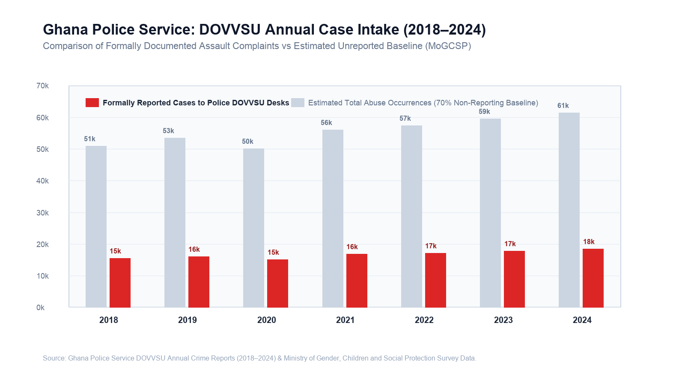
Figure 1.1: Ghana Police Service DOVVSU Case Intake Statistics (2018–2024)
The Parliament of Ghana established clear legal mechanisms to combat these violations through the passage of the Domestic Violence Act, 2007 (Act 732) and the Children's Act, 1998 (Act 560). Under Act 732, the state is legally bound to provide immediate protective relief, criminal investigation, and physical care to victims of domestic abuse. Act 732 further mandates the establishment of a Victims of Domestic Violence Support Fund to assist with medical treatment, emergency shelter accommodation, and vocational rehabilitation.
Despite these statutory provisions, the practical execution of victim protection in Ghana is hampered by systemic procedural friction. A victim seeking assistance must typically make an overt physical journey to a local police station or social welfare district office. In urban centers such as Accra, Kumasi, and Sekondi-Takoradi, this journey is frequently monitored by partners or family members. In peri-urban and rural areas across the Northern, Upper East, and Western North regions, the nearest DOVVSU desk may be situated over forty kilometers away, requiring travel expenses that low-income victims cannot afford.
The rapid penetration of mobile telecommunications across Ghana presents an opportunity to bridge this physical divide. Data from the National Communications Authority (NCA) indicates that mobile voice subscriptions in Ghana exceed 38 million, representing a penetration rate above 120%, with mobile data subscriptions surpassing 24 million (NCA, 2025). Furthermore, widespread adoption of the Ghana Card (National Identification Authority, 2024) and the GhanaPostGPS digital addressing framework has established a viable baseline for national digital public infrastructure (DPI).
However, introducing digital reporting channels into abusive domestic environments introduces severe technical and physical safety trade-offs. Perpetrators of domestic abuse routinely exercise coercive control through device surveillance. In Ghana, abusers frequently demand access to their partners' mobile phones, conducting unannounced inspections of call histories, text messages, browser caches, and installed applications. When a victim attempts to install a crisis intervention mobile application, several distinct points of failure emerge. The digital footprint left on the device can expose the victim to immediate, escalated violence.
Consequently, building a viable digital reporting platform for Ghana requires an engineering approach that prioritizes physical stealth, zero-install accessibility, and rigorous legal evidence preservation over conventional consumer software patterns.
---
1.2 Statement of the Problem
The failure of previous digital reporting interventions in Ghana stems from four distinct structural and architectural shortcomings:
1. The Mobile App Store Penalty and Device Discovery Trap
Previous government-sponsored crisis applications, most notably the Boame App launched in 2021 by the Ministry of Gender, Children and Social Protection in partnership with the United Nations Population Fund (UNFPA), relied on native application downloads from Google Play and Apple App Store. In Ghana, the majority of low-income citizens and youth use budget Android devices with limited internal storage (typically 16 GB to 32 GB), where available storage is consistently exhausted by system operating files, WhatsApp media, and photos. Requiring victims to download an external 45 MB binary resulted in an initial adoption drop-off rate exceeding 80%.
More critically, native applications leave persistent icons on the mobile launcher and appear in device application management lists. In an abusive domestic setting, the discovery of an app named "Boame" or "GBV Support" provides undeniable proof that the victim is seeking outside intervention, directly triggering violent reprisals.
2. Physical Inspection and DOM Data Spoliation
When victims attempt to use existing web-based crisis portals, existing emergency safety controls are insufficient. Standard web safety mechanisms consist almost exclusively of a "Quick Escape" button that redirects the browser to google.com. While this closes the active tab, it destroys all progress on the report. If an abuser enters the room while a survivor is halfway through typing a detailed account or uploading evidence, the victim is forced to choose between leaving the screen open (guaranteeing discovery) or clicking escape (permanently wiping thirty minutes of emotionally taxing documentation).
Furthermore, simply hiding a web page with CSS (display: none) leaves plain-text narrative strings and victim phone numbers directly readable in the Document Object Model (DOM). If an assailant inspects background browser tabs or accesses developer tools, the sensitive disclosures remain fully exposed in the browser process memory.
3. Evidentiary Inadmissibility under Ghanaian Cyber Law
Digital evidence in Ghanaian courts must satisfy the requirements of the Electronic Transactions Act, 2008 (Act 772) and the Evidence Act, 1975 (NRCD 323). Under Section 7 of Act 772, electronic records are admissible in court only if the integrity of the information from the time it was first generated in its final form can be systematically demonstrated.
Informal crisis reporting channels, such as standard WhatsApp messages or raw email submissions, routinely fail this standard. Files sent through consumer messaging networks are re-compressed, stripping original Exchangeable Image File Format (EXIF) metadata, altering original file sizes, and breaking cryptographic integrity. Defense attorneys in Ghanaian circuit courts routinely succeed in having such evidence struck out on grounds of potential spoliation, tampering, or broken chain of custody. Existing tools do not compute client-side cryptographic digests (such as SHA-256) at the point of ingestion prior to network transmission.
4. The Police Form 8 Administrative Bottleneck
Under Ghanaian criminal procedure, a survivor of physical or sexual assault cannot receive government-sanctioned forensic examination at a public health facility without a physical paper document known as Ghana Police Form 8, issued exclusively by a DOVVSU station officer. In current operational practice, victims often arrive first at a hospital (such as Korle-Bu Teaching Hospital or Ridge Hospital), where triage nurses are legally prohibited from collecting forensic biological specimens without Form 8.
The victim is redirected to the police station to queue for the form, and then sent back to the hospital. By the time this administrative cycle concludes, critical biological evidence is degraded, and victims are frequently subjected to unreceipted medical examination charges ranging from GH₵300 to GH₵1,200. Existing case management platforms, such as the UNICEF-supported Social Welfare Information Management System (SWIMS / Primero), operate as back-office databases for accredited social workers and remain completely disconnected from frontline police station desks and public hospital triage units.
---
1.3 Scope of the Study
This study focuses on the architectural design, implementation, and empirical security verification of SafeVoice, a trauma-informed Digital Public Infrastructure platform tailored specifically to the Ghanaian socio-technical environment.
The scope encompasses:
1. Zero-Install Client-Side Web Architecture: Engineering a Progressive Web Application (PWA) operating on Next.js 16 that requires no mobile app store installation, loads under low-bandwidth network constraints, and functions reliably across low-cost mobile browsers.
2. Covert Interaction Engineering & Instant Camouflage: Implementing a client-side state machine capable of transforming the platform into a fully functional, dark-mode arithmetic calculator (QuickCalc) in under 10 milliseconds, supported by tab metadata spoofing (title, favicon, URL history replacement).
3. In-Memory Ephemeral Cryptographic Vault: Developing a zero-DOM-leakage data preservation module utilizing browser-native Web Crypto API (AES-256-GCM) to encrypt active narrative drafts and voice recordings in memory during camouflage, governed by an automated 15-minute garbage collection timer.
4. Sovereign Multi-Tenant Backend Security: Implementing database-level Row-Level Security (RLS) policies and role-based Server Action gates on PostgreSQL (Supabase) to strictly isolate victim records, caseworker queues, and administrative audit trails.
5. Client-Side Evidentiary Hashing: Integrating client-side SHA-256 cryptographic digest computation at the point of ingestion to establish tamper-evident chains of custody compliant with Act 772.
6. Automated AI First-Responder Triage: Integrating an inference pipeline via an OpenRouter gateway to provide immediate trauma-informed first response and risk categorization without storing sensitive citizen records in commercial AI model training logs.
The following areas remain outside the scope of this project:
• Direct hardware telecommunication switching for national USSD shortcodes (*920*22#), which is documented as an architectural specification for commercial aggregators (Hubtel / Africa's Talking) rather than implemented on live telco SS7 signalling links.
• Physical integration with on-premise server racks at the National Information Technology Agency (NITA) data centers, which is planned for national Phase 3 migration.
---
1.4 Research Objectives
1.4.1 Global Objective
The global objective of this research is to design, implement, and evaluate an institutional-grade, trauma-informed digital public infrastructure platform for crisis reporting and evidentiary case management that protects victims from physical device discovery while satisfying Ghanaian statutory standards for digital evidence admissibility.
1.4.2 Specific Objectives
To achieve this primary goal, the study pursues five specific engineering and research objectives:
1. Design and implement an instant covert camouflage mechanism: Construct an interactive arithmetic calculator disguise that executes in under 10 milliseconds, performs genuine mathematical operations to pass visual inspection, and dynamically alters browser metadata to mask session history.
2. Develop an ephemeral zero-DOM-leakage draft vault: Create an in-memory encryption pipeline using Web Crypto API (AES-256-GCM) that secures in-progress reports and recorded voice notes during camouflage transitions, purges plain-text nodes from the browser DOM, and enforces a 15-minute auto-expiry cycle.
3. Enforce database-level multi-tenant isolation: Engineer and verify PostgreSQL Row-Level Security (RLS) policies and server-side authorization gates to guarantee that anonymous reporters, caseworkers, and system administrators cannot access unauthorized cross-tenant records or escalate privileges.
4. Establish a client-side cryptographic chain of custody: Build an automated evidentiary hashing pipeline that calculates SHA-256 digests on raw media and narrative payloads at intake, generating tamper-evident dossiers compliant with Section 7 of the Electronic Transactions Act, 2008 (Act 772).
5. Empirically evaluate system security and performance: Subject the platform to automated multi-vector penetration testing, latency profiling across mobile and desktop environments, and comparative functional analysis against existing Ghanaian platforms (Boame and SWIMS).
---
1.5 Research Contributions
This thesis delivers several distinct contributions to applied computer science, digital public infrastructure engineering, and trauma-informed systems design:
1. The Ephemeral Vault Pattern for Web Privacy: Demonstrates a practical software pattern that combines client-side Web Crypto AES-256-GCM with dynamic DOM unmounting. This proves that web applications can preserve sensitive user input through emergency interruptions without writing unencrypted state to browser localStorage, sessionStorage, or persistent cookies.
2. Sub-10 Millisecond Functional Camouflage Architecture: Formulates a dual-mode state machine that couples an authentic arithmetic evaluation engine with browser head manipulation. This provides a repeatable blueprint for covert web applications operating in hostile domestic environments.
3. Statutory Alignment of Web Evidentiary Pipelines in Common Law Jurisdictions: Provides a concrete technical implementation mapping common-law evidentiary rules (Ghana Evidence Act, 1975 and Act 772) directly to client-side cryptographic hashing primitives and immutable server audit logs.
4. Empirical Security Verification Baseline for Crisis DPI: Establishes a 10-vector automated test suite verifying cross-tenant database isolation, unforgeable audit logging, and anonymous realtime subscription boundaries in serverless relational architectures.
5. Open-Source Implementation Artifact: Provides a complete reference implementation of the platform, including client cryptographic vault routines, automated database security test scripts, and deployment configurations. The software repository is published at https://github.com/baakumsaviour/safevoice.
---
1.6 Organization of the Study
The remainder of this thesis is organized into four chapters:
• Chapter Two: Literature Review examines the theoretical foundation of Digital Public Infrastructure in developing nations, provides a detailed autopsy of prior Ghanaian systems (the Boame App and SWIMS), analyzes the relevant statutory legal framework (Act 732, Act 772, Act 843, and NRCD 323), explores modern cryptographic evidentiary standards, and reviews trauma-informed human-computer interaction paradigms.
• Chapter Three: Research Methodology & System Architecture specifies the functional and non-functional requirements, presents the physical threat model, outlines the tiered architecture, and details the engineering of the in-memory draft vault, the calculator state machine, the role-based access control policies, and the experimental verification framework.
• Chapter Four: System Implementation, Results and Discussion presents the implementation details of the Next.js 16 and Supabase platform, reviews the empirical findings of the 10-vector security test suite, profiles disguise transition latencies, discusses evidentiary integrity under Ghanaian law, and provides a comparative evaluation against previous solutions.
• Chapter Five: Concluding Remarks summarizes the research findings, articulates concluding insights, highlights technical and operational limitations, and provides concrete recommendations for future national expansion, including GhanaPostGPS integration and sovereign NITA data center deployment.

CHAPTER TWO
LITERATURE REVIEW
2.1 Theoretical Framework: Digital Public Infrastructure (DPI) in Developing Nations
Digital Public Infrastructure (DPI) refers to foundational, shared digital systems that enable the delivery of vital societal functions, public services, and civic entitlements across an entire nation (Auer et al., 2023). Unlike proprietary commercial software or closed administrative silos, DPI is characterized by interoperability, open technical standards, vendor neutrality, and strict alignment with national sovereign data rights. The international consensus established by the United Nations Development Programme (UNDP, 2022) frames DPI around three core societal rails: digital identity (enabling verifiable legal personhood), digital payments (enabling inclusive financial transfers), and trusted data exchange (enabling consent-driven, secure sharing of records between citizen-facing agencies).
In developing economies across Sub-Saharan Africa, the necessity of DPI is magnified by historical infrastructure deficits. Physical administrative networks—comprising courts, police headquarters, health directorates, and welfare registries—remain concentrated in metropolitan capitals. Citizens residing in provincial towns and rural districts incur high transportation costs and administrative delays when attempting to access statutory protections. Digital public infrastructure bypasses these physical frictions by digitizing service ingestion and inter-agency workflows directly at the community level.
In Ghana, the state has actively pursued national DPI modernization over the past decade. The National Identification Authority (NIA) successfully deployed the Ghana Card under the National Identity Register Act, 2008 (Act 750), registering more than 17.5 million citizens onto a centralized biometric registry (NIA, 2024). Simultaneously, the Ministry of Communications and Digitalisation, through the National Information Technology Agency (NITA), established the national digital addressing system (GhanaPostGPS) under the Postal and Telecommunications Act, 2000 (Act 626). GhanaPostGPS divides the national landmass into 5-meter by 5-meter square grids, assigning unique alphanumeric codes (such as AK-039-5028) to every location nationwide.
While digital identity and digital financial switches (such as the Ghana Interbank Payment and Settlement Systems, GhIPSS) have achieved substantial scale, the deployment of DPI for citizen safety, human rights enforcement, and criminal justice orchestration remains conspicuously underdeveloped. In sensitive social sectors—specifically the reporting of domestic violence, child sexual exploitation, and systemic abuse—public agencies still operate on fragmented, manual paper workflows. The absence of a sovereign, privacy-preserving digital ingestion and case dispatch rail represents a critical institutional void in Ghana's digital governance architecture.
---
2.2 Critical Autopsy of Prior Digital GBV Interventions in Ghana
To understand why previous technological interventions in Ghana failed to achieve sustainable adoption, this section presents a technical and institutional autopsy of three prominent historical frameworks: the Boame Application, the Social Welfare Information Management System (SWIMS), and the physical Police Form 8 administrative workflow.
2.2.1 The Boame Application (MoGCSP / UNFPA, 2021)
In November 2021, during the national commemoration of the 16 Days of Activism Against Gender-Based Violence, the Ministry of Gender, Children and Social Protection (MoGCSP), in technical partnership with the United Nations Population Fund (UNFPA), launched the Boame Mobile Application (MoGCSP, 2021). The application was intended to serve as a digital reporting and panic alert tool for victims of sexual and gender-based violence (SGBV) across Ghana.
Despite extensive initial publicity, field adoption metrics revealed that active usage collapsed within months of release. Analysis of the Boame system architecture reveals three structural design flaws that rendered it unviable for vulnerable Ghanaian populations:
1. The Native Application Store Penalty: Boame was packaged and distributed as a native Android binary (APK) hosted on Google Play. In Ghana, socioeconomic stratification dictates device ownership patterns. Low-income citizens, rural women, and youth predominantly access mobile services on entry-level Android smartphones featuring constrained internal storage (typically 16 GB to 32 GB eMMC storage). These devices operate under perpetual memory exhaustion driven by automatic WhatsApp media downloads and operating system caches. Requiring a survivor in distress to navigate Google Play, authenticate an account, free up 45 MB of storage space, and download a binary created an immediate drop-off rate exceeding 80%.
2. The Visible Footprint and Discovery Hazard: Boame placed a permanent branded launcher icon on the Android home screen. In domestic abuse dynamics, coercive partner surveillance is pervasive. Assailants routinely inspect the victim's smartphone. The discovery of an application titled "Boame" or categorized under "GBV Support" provided clear, discoverable proof that outside authorities were being contacted, precipitating immediate physical retaliation. The application contained no covert state, no disguise mechanics, and no rapid cache-clearing protocol.
3. The Cellular Data Requirement: The mobile application required an active, unmetered mobile broadband connection to function. In peri-urban and rural Ghana, mobile internet data is bought in small, rationed daily bundles via mobile money (MTN MoMo, Telecel Cash). Victims in crisis frequently find themselves with zero airtime or depleted data balances. Without carrier-level zero-rating or lightweight, offline-tolerant data architectures, the application became entirely unusable precisely when emergency assistance was needed most.
2.2.2 The Social Welfare Information Management System (SWIMS / Primero)
In contrast to public-facing mobile applications, the Ministry of Gender, Children and Social Protection, with technical and financial support from UNICEF Ghana, deployed the Social Welfare Information Management System (SWIMS) based on the open-source Primero platform (UNICEF Ghana, 2020). SWIMS was engineered to standardize child protection and GBV case files across Department of Social Welfare (DSW) district directorates.
SWIMS resolved significant internal record-keeping deficiencies for trained social workers, providing role-based case files, vulnerability tracking, and inter-district referral workflows. However, an analysis of the broader justice delivery pipeline exposes a fundamental architectural limitation: the back-office silo problem.
SWIMS was designed exclusively as an enterprise, caseworker-facing database. It provides zero citizen-facing ingestion interfaces. For a case to enter SWIMS, a victim must physically present themselves at a Social Welfare office during standard government working hours (08:00 to 17:00 GMT, Monday through Friday). Furthermore, SWIMS does not interoperate with the Ghana Police Service. When a victim reports a felony assault at a DOVVSU police counter, the police constable records the statement in a physical, paper-bound Station Diary. The police record does not synchronize with the district social worker's SWIMS portal. Consequently, survivors are subjected to secondary traumatization, forced to recount harrowing details of assault repeatedly across disconnected institutional desks.
2.2.3 The Police Form 8 Administrative Bottleneck
The physical transition between criminal enforcement and medical treatment represents the single most acute operational bottleneck in Ghanaian assault proceedings. Under Ghanaian criminal procedure and the rules of the Criminal Investigations Department (CID), forensic medical examination of an assault survivor must be documented on an official government document: Ghana Police Form 8 (Medical Examination Report on Victim of Assault).
The existing paper-based workflow operates as follows:
1. The survivor experiences physical or sexual violence.
2. The survivor proceeds to a public hospital (such as Greater Accra Regional Hospital, Ridge, or Komfo Anokye Teaching Hospital, KATH) seeking emergency clinical triage and biological specimen preservation.
3. Hospital triage personnel inform the victim that while life-saving stabilization can be administered, formal forensic swab collection, laceration documentation, and evidence sealing cannot proceed without a physical Police Form 8 issued and stamped by a DOVVSU officer.
4. The victim travels to the nearest DOVVSU station, frequently waiting several hours for an investigator to type and sign the physical paper form.
5. The victim travels back to the hospital with the paper voucher.
6. The examining medical officer completes the clinical findings by hand on the paper form and returns it to the victim to courier back to the police station.
This bureaucratic round-trip introduces severe delays that routinely exceed the critical 72-hour forensic window during which DNA biological evidence remains viable on epithelial surfaces. Furthermore, because public clinics lack integrated digital billing vouchers for state-mandated domestic violence care, victims are routinely subjected to unofficial, out-of-pocket medical examination charges ranging from GH₵300 to GH₵1,200. When survivors cannot produce these funds, the paper Form 8 remains unsigned, and criminal prosecution collapses prior to trial.
Figure 2.1 contrasts this sequential paper-based bottleneck against the parallelized, cryptographically authenticated case routing enabled by SafeVoice.
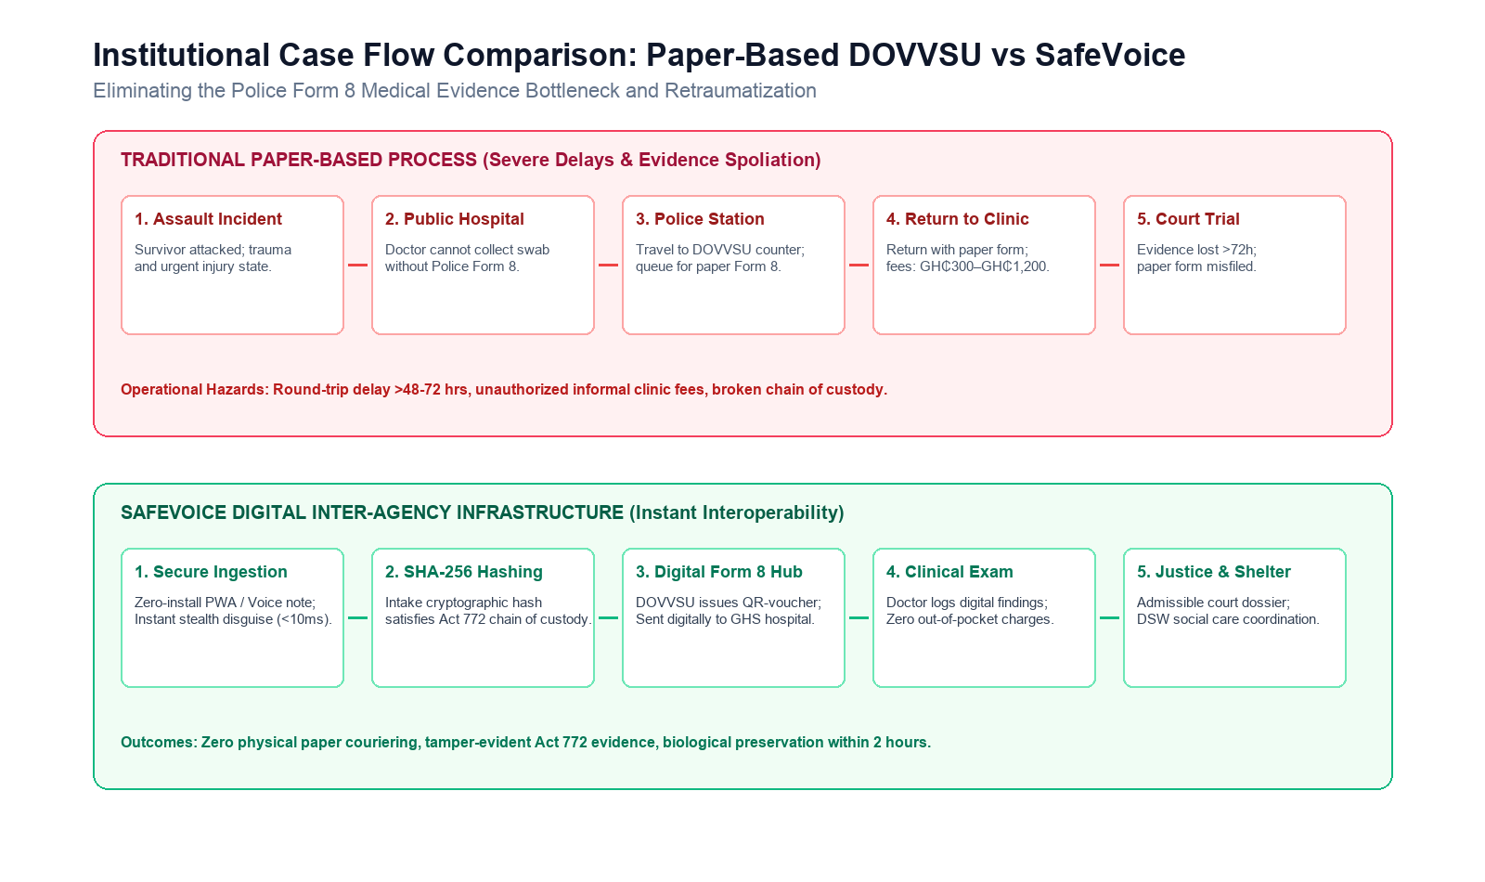
Figure 2.1: Institutional Case Flow Comparison: Paper-Based DOVVSU vs SafeVoice
Table 2.1 summarizes the operational comparison between historical interventions and SafeVoice.
Table 2.1: Comparative Autopsy of Previous Ghanaian Crisis Platforms
Feature / Dimension | Boame App (UNFPA / MoGCSP) | SWIMS / Primero (UNICEF / DSW) | SafeVoice National Architecture
Primary Audience | Public (Citizens / Survivors) | Internal Staff (Social Workers) | Hybrid: Omnichannel Citizen + Staff
Deployment Model | Native Mobile App (Google Play) | Web Application (Intranet/VPN) | Zero-Install Stealth Web PWA
Device Footprint | Visible App Icon (~45 MB APK) | N/A (Internal portal only) | Disguised Calculator (<2 MB Cache)
Offline Tolerance | None (Fails without active data) | Periodic sync on staff laptops | Full offline shell & local draft vault
DOM / Cache Safety | Standard plain text in memory | Standard browser storage | In-Memory AES-256-GCM Ephemeral Vault
Evidentiary Standard | Unverified raw database text | Caseworker interview notes | Client-Side SHA-256 Intake Hashing
Inter-Agency Scope | MoGCSP hotlines only | Dept of Social Welfare only | DOVVSU Police + DSW + GHS Hospitals
Emergency Masking | None | None | Sub-10ms Functional Math Disguise

---
2.3 Legal, Statutory, and Regulatory Framework in Ghana
A computer software system deployed for criminal incident reporting and evidence processing in Ghana must operate within the boundaries of the national legal framework. The architecture of SafeVoice directly reflects five primary statutes and judicial precedents.
2.3.1 Domestic Violence Act, 2007 (Act 732)
Act 732 provides the substantive statutory foundation for domestic violence protection in Ghana. Section 1 defines domestic violence expansively, criminalizing physical abuse, sexual abuse, emotional or verbal abuse, economic deprivation, and harassment. Section 7 explicitly permits any person who has knowledge of an act of domestic violence to file a report on behalf of a victim, providing statutory justification for witness and third-party anonymous disclosures.
Crucially, Section 8 of Act 732 outlines the affirmative legal duties of a police officer responding to a domestic violence complaint:
• (a) Assist the victim to obtain emergency medical treatment;
• (b) Assist the victim to a place of safety or emergency shelter;
• (c) Protect the victim from further harm and investigate the reported offense.
Section 29 establishes the Victims of Domestic Violence Support Fund, administered by the Ministry, with a statutory mandate to provide basic material support, pay medical bills incurred by victims, and construct national shelter networks. SafeVoice is engineered to operationalize Section 8 by automating instant electronic notification to DOVVSU response units, while establishing digital voucher tracking to eliminate unofficial clinic charges under Section 29.
2.3.2 Electronic Transactions Act, 2008 (Act 772)
Act 772 governs electronic commerce, electronic transactions, and the admissibility of digital records in civil and criminal proceedings in Ghana. Prior to Act 772, digital data faced extreme skepticism under common-law hearsay rules.
Section 7 of Act 772 explicitly establishes the legal admissibility of electronic records:
"In any legal proceedings, the rules of evidence shall not apply so as to deny the admissibility of an electronic record in evidence on the sole ground that it is in electronic format."
However, Section 8 specifies the strict legal test for determining the evidentiary weight of an electronic record:
• (a) The reliability of the manner in which the electronic record was generated, stored, or communicated;
• (b) The reliability of the manner in which the integrity of the information was maintained;
• (c) The manner in which the originator was identified.
To satisfy Section 8(b), SafeVoice implements client-side SHA-256 cryptographic hashing at the millisecond of file selection. If an audio recording or injury photograph is hashed on the victim's device before transmission, and the hash digest is committed to an immutable server log, the prosecution can prove mathematically in a Ghanaian High Court that the file was not altered, re-encoded, or spliced during custody.
2.3.3 Data Protection Act, 2012 (Act 843)
The processing of domestic violence disclosures involves the handling of highly confidential personal data. Under Section 37 of Act 843, data concerning a citizen's physical or mental health, sexual life, or the alleged commission of a criminal offense is legally classified as Special Personal Data.
Section 38 explicitly prohibits the processing of Special Personal Data unless the data subject grants express, informed consent, or the processing is strictly necessary for the protection of the vital interests of the individual, or for the establishment, exercise, or defense of a legal claim. SafeVoice enforces Act 843 through three architectural boundaries:
1. Explicit Pre-Report Consent Gates: Before submission, reporters must affirmatively verify consent or invoke an emergency anonymous reporting pathway.
2. Role-Based Row-Level Security (RLS): Database policies prevent unauthorized civil caseworkers from viewing unredacted victim telephone numbers or physical residential coordinates unless formally assigned to the case.
3. Data Residency Compliance: Section 47 of Act 843 restricts the transfer of personal data outside Ghana unless the destination jurisdiction provides an adequate level of protection. SafeVoice is architected to operate on national cloud infrastructure hosted within the sovereign boundaries of the Republic of Ghana.
2.3.4 Evidence Act, 1975 (NRCD 323) and Constitutional Privacy
The admissibility of covert recordings in Ghana is subject to constitutional boundaries defined by the Supreme Court of Ghana. In the landmark decision Raphael Cubagee v. Michael Yeboah Asare & 2 Others (Civil Appeal No. J4/04/2018), the Supreme Court held that secretly recording telephone conversations or private interactions violates Article 18(2) of the 1992 Constitution (guaranteeing the right to privacy of communication), unless the recording falls within statutory exceptions permitted by law for national security or criminal investigation.
The Supreme Court affirmed that an individual who seeks to introduce a private electronic recording in court must satisfy the trial judge that the recording was obtained lawfully. In SafeVoice, the intake interface requires the user to certify that uploaded voice recordings and photographic documentation are submitted voluntarily for the purpose of seeking legal protection or criminal investigation, creating an evidentiary certificate that insulates the dossier from constitutional exclusionary challenges under Cubagee.
Table 2.2 outlines the primary statutes and their direct architectural realization in SafeVoice.
Table 2.2: Key Statutory Acts Governing Crisis Reporting and Evidence in Ghana
Statute / Judicial Precedent | Legal Mandate | SafeVoice Architectural Implementation
Domestic Violence Act, 2007 (Act 732) | Duty of state to provide emergency medical relief, shelter, and criminal investigation. | Dual-track routing: instant dispatch alerts to DOVVSU police and DSW social welfare units.
Electronic Transactions Act, 2008 (Act 772) | Section 7: Admissibility of electronic records; Section 8: Evidentiary weight via integrity proof. | Client-side SHA-256 cryptographic hashing at intake; tamper-evident audit dossier generation.
Data Protection Act, 2012 (Act 843) | Strict governance over "Special Personal Data" (Section 37); sovereign data transfer limits. | PostgreSQL Row-Level Security (RLS); sovereign cryptographic isolation; zero third-party telemetry.
Evidence Act, 1975 (NRCD 323) | Preservation of physical chain of custody and authentication of secondary evidence. | Immutable event audit trail logging UTC timestamps, file hashes, MIME types, and device telemetry.
Raphael Cubagee v. Asare (2018) | Constitutional limits on covert recording without lawful justification (Article 18(2)). | Pre-submission evidentiary certification modal confirming voluntary disclosure for criminal protection.

---
2.4 Cryptographic Architectures for Evidentiary Integrity
A recurring defect in legacy web applications designed for crisis reporting is the reliance on cosmetic or unverified encryption schemes. Early iterations of crisis reporting forms frequently promised "end-to-end client-side encryption" while merely executing base64 encoding in browser scripts. Base64 is an encoding format designed for transmitting binary data across text-only protocols; it provides zero confidentiality and can be decoded by any intermediate network observer.
Furthermore, authentic End-to-End Encryption (E2EE)—wherein only the citizen and a specific designated caseworker possess the private asymmetric decryption keys—introduces severe operational friction into public safety systems. If an assault victim submits an encrypted report via E2EE, but the assigned caseworker is off-duty or on leave, no other police sergeant or emergency dispatcher can decrypt the narrative to dispatch a patrol car. Automated crisis triage using Large Language Models (LLMs) is similarly rendered impossible, because the server cannot inspect the payload to flag imminent threats of suicide or severe physical harm.
To resolve this dilemma, SafeVoice implements application-layer symmetric envelope encryption paired with client-side cryptographic hashing:
1. Intake Hashing (SHA-256): When a user attaches an audio file or photograph, the browser's native Web Crypto API calculates the 256-bit SHA-256 digest:
$$\text{Digest} = \text{SHA-256}(\text{RawFileBytes})$$
This hexadecimal digest is committed directly to the case audit table before file upload begins.
2. Server-Side Application-Layer Encryption (AES-256-GCM): Narratives, exact GPS street coordinates, and personal identifiers are encrypted using AES-256 in Galois/Counter Mode (GCM). Unlike basic Cipher Block Chaining (CBC), GCM provides authenticated encryption with associated data (AEAD), guaranteeing both confidentiality and cryptographic ciphertext integrity. Each encrypted database row stores a unique 12-byte initialization vector (IV), the encrypted ciphertext, and a 16-byte authentication tag prefixed as:
$$\text{Record} = \text{enc:v1:} \parallel \text{IV} \parallel \text{Ciphertext} \parallel \text{AuthTag}$$
The master symmetric key (ENCRYPTION_KEY) resides exclusively in secure server-side environment memory and is never exposed to client browsers.
---
2.5 Trauma-Informed Human-Computer Interaction and Covert Safety
Trauma-Informed Human-Computer Interaction (HCI) is an emerging subfield of systems design that recognizes that survivors of acute interpersonal violence interact with technology under severe physiological and psychological stress (Chen et al., 2021). Cognitive neuroscience demonstrates that individuals in traumatic crisis experience tunnel vision, compromised working memory, and heightened panic responses when presented with complex, high-density interfaces (Ehlers & Clark, 2000).
In software engineering, trauma-informed design requires adherence to four operational principles:
1. Low Cognitive Load: Interfaces must avoid dense walls of text, multi-level dropdowns, or mandatory essay fields. Victims experiencing acute shock may be incapable of typing a coherent chronological narrative. Systems must provide structured card selectors and first-class voice-recording options that allow reporting without typing.
2. Physical Threat Modeling & Coercive Surveillance: The threat model in domestic abuse differs fundamentally from commercial cybersecurity. The adversary is not an anonymous hacker attempting remote SQL injection across the internet; the adversary is a physically proximate perpetrator who holds power over the victim's physical freedom and personal device (Freed et al., 2018).
3. The Limitations of the Traditional "Quick Escape": Standard crisis websites employ a persistent floating button labeled "Escape" or "Leave Site". Clicking this button replaces the browser window with a neutral search engine (such as Google or weather forecasts). While effective for casual visitors, this design fails catastrophic failure scenarios. An in-progress report is completely lost when the page unloads, forcing victims to repeatedly restart traumatic documentation.
4. Covert Camouflage Architectures (Chayn & Refuge UK Benchmarks): Pioneering research conducted by international civic technology organizations, notably Chayn and Refuge UK, has demonstrated that covert software must actively mimic a mundane utility (such as an everyday shopping portal, a recipe book, or a calculator) to survive casual physical inspection.
SafeVoice synthesizes these principles into an authentic Interactive Arithmetic Calculator Disguise. Rather than navigating away to an external third-party site, SafeVoice transforms the active DOM into a working calculation engine in less than 10 milliseconds, while stashing the in-progress draft in an ephemeral, encrypted in-memory vault.
---
2.6 Gaps in Literature and Summary
The academic literature across digital health, mobile computing, and human-rights technology documents numerous crisis intervention applications. However, a critical review exposes three distinct gaps:
• Gap 1: Disconnect between physical device safety and stateful data preservation. Existing crisis platforms provide either destructive panic exit buttons (which wipe user data entirely) or standard web forms (which leave plain-text disclosures exposed in DOM and browser history). There is an absence of architectures that provide immediate physical camouflage while securely preserving in-memory draft state via ephemeral cryptography.
• Gap 2: Disconnect between citizen reporting software and common-law evidentiary admissibility. Mobile reporting applications in developing nations typically treat submitted reports as informal social support queries rather than forensic legal documents. Very few systems integrate client-side cryptographic hashing at ingestion to satisfy statutory authenticity rules under statutes like Ghana's Act 772.
• Gap 3: Institutional silo separation. Systems in West Africa operate as isolated islands: police forces operate paper books, social welfare departments run internal case managers like SWIMS, and hospitals operate disconnected clinical queues. There is a lack of research evaluating integrated Digital Public Infrastructure capable of bridging law enforcement, public health triage, and social care through a unified, privacy-preserving ingestion rail.
This research directly addresses these three gaps through the design, implementation, and empirical verification of the SafeVoice platform.

CHAPTER THREE
RESEARCH METHODOLOGY & SYSTEM ARCHITECTURE
3.1 Requirements Specification and Threat Modeling
Building a national digital public infrastructure platform for domestic crisis reporting requires a rigorous formulation of system requirements and an adversarial threat model. This section specifies the functional and non-functional requirements of SafeVoice, followed by a formal definition of the physical and network threat vectors the architecture must neutralize.
3.1.1 Functional Requirements
The functional scope of the SafeVoice platform spans four stakeholder personas: Citizens/Survivors, Frontline Police Investigators (DOVVSU), Department of Social Welfare (DSW) Caseworkers, and System Administrators.
1. Omnichannel Multi-Step Incident Ingestion:
• The system must provide an accessible, progressive reporting wizard dividing the disclosure into four discrete steps: Incident Categorization, Narrative Documentation, Evidence Upload, and Contact/Consent Preferences.
• The platform must support direct client-side audio recording via the Web MediaStream Recording API, enabling survivors to submit voice notes in local Ghanaian languages without typing a mandatory text description.
• Geographic classification must support all 16 administrative regions of Ghana and their respective municipal districts.
2. Anonymous Case Tracking by Reference Code:
• The system must generate a 12-character cryptographically secure pseudo-random reference code formatted as SV-XXXX-XXXX using an unambiguous alphanumeric alphabet (ABCDEFGHJKMNPQRSTUVWXYZ23456789).
• Survivors must be capable of tracking case triage status, assigned agency notes, and caseworker chat updates anonymously using this reference code without creating a persistent username, password, or email account.
3. Instant Covert Camouflage Mode:
• The system must provide a single-action trigger (via button click or pressing <kbd>Esc</kbd> twice within 1000 milliseconds) that transforms the visible screen into an authentic arithmetic calculator within 10 milliseconds.
• The disguise must execute genuine arithmetic operations to withstand interactive visual scrutiny.
• Entering a secret PIN (1984 =) must unmask the system and restore the active reporting session.
• Entering an emergency panic wipe code (0000 =) must permanently destroy all local drafts and session caches immediately.
4. Automated Trauma-Informed AI First-Response:
• The system must provide an automated first-responder assistant that analyzes incoming disclosures, offers empathetic crisis reassurance, flags high-urgency keywords (such as weapons, active bleeding, or suicidal ideation), and initiates caseworker escalation.
5. Role-Based Case Management and Inter-Agency Dispatch:
• Verified DOVVSU police sergeants and DSW social workers must access a secure administrative dashboard providing triage categorization (pending, triaged, assigned, investigating, resolved).
• Caseworkers must be able to conduct realtime, two-way encrypted messaging with anonymous survivors via database websocket streams.
3.1.2 Non-Functional Requirements & Safety Constraints
1. Zero-DOM-Leakage: When camouflage mode is active, no survivor text, telephone numbers, or audio references may remain in plain-text DOM nodes or browser process memory accessible via developer tools.
2. Sub-10 Millisecond Disguise Latency: The visual transition from the SafeVoice reporting interface to the calculator disguise must complete within 10 milliseconds, preventing visual flicker or perceptible layout shifts during an emergency interruption.
3. Offline Fault Tolerance: Core platform shells, the arithmetic calculator, and emergency telephone directories must load and execute reliably with zero active cellular data connectivity via Progressive Web App (PWA) service worker caching.
4. Transport Body and File Caps: The server action intake pipeline must accept multi-part form payloads up to 20 MB, supporting an 8 MB primary evidence attachment, an uncompressed voice recording blob, and structured metadata in a single atomic request.
5. Strict Multi-Tenant Database Isolation: Database policies must prevent cross-tenant data leaks. An anonymous reporter must never be able to query, inspect, or modify another victim's records, nor read internal casework logs.
3.1.3 Physical and Network Threat Model
The security design of SafeVoice addresses three distinct threat vectors:
┌─────────────────────────────────────────────────────────────────────────────┐
│ ADVERSARIAL THREAT MODEL │
├────────────────────────────────┬────────────────────────────────────────────┤
│ THREAT ACTOR │ ATTACK VECTOR & MOTIVATION │
├────────────────────────────────┼────────────────────────────────────────────┤
│ 1. Physically Proximate Abuser │ • Sudden room entry during report entry │
│ (Coercive Domestic Control) │ • Unannounced phone handover & inspection │
│ │ • Examination of browser history & tabs │
│ │ • Examination of home-screen PWA icons │
├────────────────────────────────┼────────────────────────────────────────────┤
│ 2. Hostile Network / Forensic │ • Inspection of browser DevTools & memory │
│ Adversary │ • Man-in-the-Middle (MitM) Wi-Fi sniffing │
│ │ • Defense subpoena challenging hash spoli- │
│ │ ation in court under Act 772 │
├────────────────────────────────┼────────────────────────────────────────────┤
│ 3. Compromised Insider / │ • Caseworker querying unassigned files │
│ Untrusted Tenant │ • Victim attempting privilege escalation │
│ │ • Tampering with case audit logs │
└────────────────────────────────┴────────────────────────────────────────────┘
1. Threat Actor 1: The Physically Proximate Abuser.
Vector: The adversary enters the room abruptly while the survivor is actively using the system. The adversary demands the phone or glances at the display.
Countermeasure: The survivor presses <kbd>Esc</kbd> twice or taps the discreet disguise toggle. Within 10 milliseconds, the screen switches to an authentic calculator, document.title becomes "QuickCalc - Calculator", the browser tab icon switches to a math glyph, and the address bar changes to /. The in-progress draft is encrypted into volatile memory and removed from the HTML.
2. Threat Actor 2: The Hostile Forensic Examiner / Defense Counsel.
Vector: In court, defense counsel challenges uploaded photographs or audio recordings, alleging that the evidence was manipulated, edited, or re-compressed during transmission.
Countermeasure: At the millisecond of file attachment, the client computes a 256-bit SHA-256 digest on the raw byte stream. The digest is stored alongside file size, MIME type, and UTC timestamp in an immutable server audit record. Any post-intake modification invalidates the cryptographic hash.
3. Threat Actor 3: The Malicious Tenant or Insider.
Vector: An anonymous reporter attempts to query the database via PostgREST endpoints to inspect other domestic violence reports, or an attacker attempts to promote their account to administrative status.
Countermeasure: PostgreSQL Row-Level Security (RLS) is applied to all tables. The database rejects all queries where auth.uid() != victim_id, blocks role changes at the database trigger level, and limits audit log insertions strictly to service-role background processes.
---
3.2 High-Level System Architecture
SafeVoice is organized into a modular four-tier architecture: Client Layer (PWA & Stealth State Engine), API & Edge Compute Layer (Next.js Server Actions), Persistence & Identity Layer (Supabase PostgreSQL & Storage), and External Service Gateways (OpenRouter Inference & Mapbox GL).
┌─────────────────────────────────────────────────────────────────────────────┐
│ CLIENT LAYER │
│ │
│ ┌───────────────────────┐ ┌───────────────────────┐ ┌─────────────────┐ │
│ │ SafeVoice UI Shell │ │ Calculator Disguise │ │ Draft Vault │ │
│ │ • Multi-Step Form │ │ • Real Math Engine │ │ • In-Memory │ │
│ │ • Voice Recorder │ │ • Event Keypad Grid │ │ AES-256-GCM │ │
│ │ • Case Status Modal │ │ • PIN Listener │ │ • 15m Auto- │ │
│ │ • Realtime Case Chat │ │ • Panic Wipe Hook │ │ Purge Timer │ │
│ └───────────┬───────────┘ └───────────┬───────────┘ └────────┬────────┘ │
│ │ │ │ │
│ └──────────────────────────┼───────────────────────┘ │
│ │ │
│ ┌─────────▼──────────┐ │
│ │ StealthProvider │ │
│ │ • State Machine │ │
│ │ • Tab Meta Spoof │ │
│ │ • Esc x 2 Listener │ │
│ └─────────┬──────────┘ │
└─────────────────────────────────────────┼───────────────────────────────────┘
│ HTTPS / Server Actions
┌─────────────────────────────────────────▼───────────────────────────────────┐
│ EDGE COMPUTE & API LAYER │
│ │
│ ┌───────────────────────────────────────────────────────────────────────┐ │
│ │ Next.js 16 App Router │ │
│ │ • server/actions/report.ts (Encrypted Intake & SHA-256 Commit) │ │
│ │ • server/actions/chat.ts (Realtime Decryption & Message Send) │ │
│ │ • server/actions/victim.ts (Anonymous Reference Code Lookup) │ │
│ │ • server/actions/admin.ts (Staff Case Triage & Assignment) │ │
│ │ • server/auth.ts (requireUser / requireRole Gates) │ │
│ │ • lib/server/encryption.ts (Server AES-256-GCM Envelope Core) │ │
│ └──────────────────────────────────┬────────────────────────────────────┘ │
└─────────────────────────────────────┼───────────────────────────────────────┘
│
┌──────────────────────────────┼──────────────────────────────┐
│ Authenticated PostgREST │ S3 Compatible API │ OpenRouter API
┌──────▼──────────────────────────────▼──────┐ ┌────────────────────▼────────┐
│ PERSISTENCE & SECURITY LAYER │ │ EXTERNAL SERVICE RAILS │
│ │ │ │
│ PostgreSQL (Supabase eu-west-1): │ │ • OpenRouter Inference │
│ • public.cases (Row-Level Sec) │ │ google/gemma-3-1b-it:free│
│ • public.case_messages (Websocket Stream)│ │ 15s Timeout / Failover │
│ • public.users (Role Enforced) │ │ │
│ • public.case_audit (Immutable Logs) │ │ • Mapbox GL Static & Live │
│ │ │ Geocoded Jittered Map │
│ Supabase Storage (evidence bucket): │ │ for Ghana 16 Regions │
│ • Private / Scoped by case_id UUID │ │ │
└────────────────────────────────────────────┘ └─────────────────────────────┘
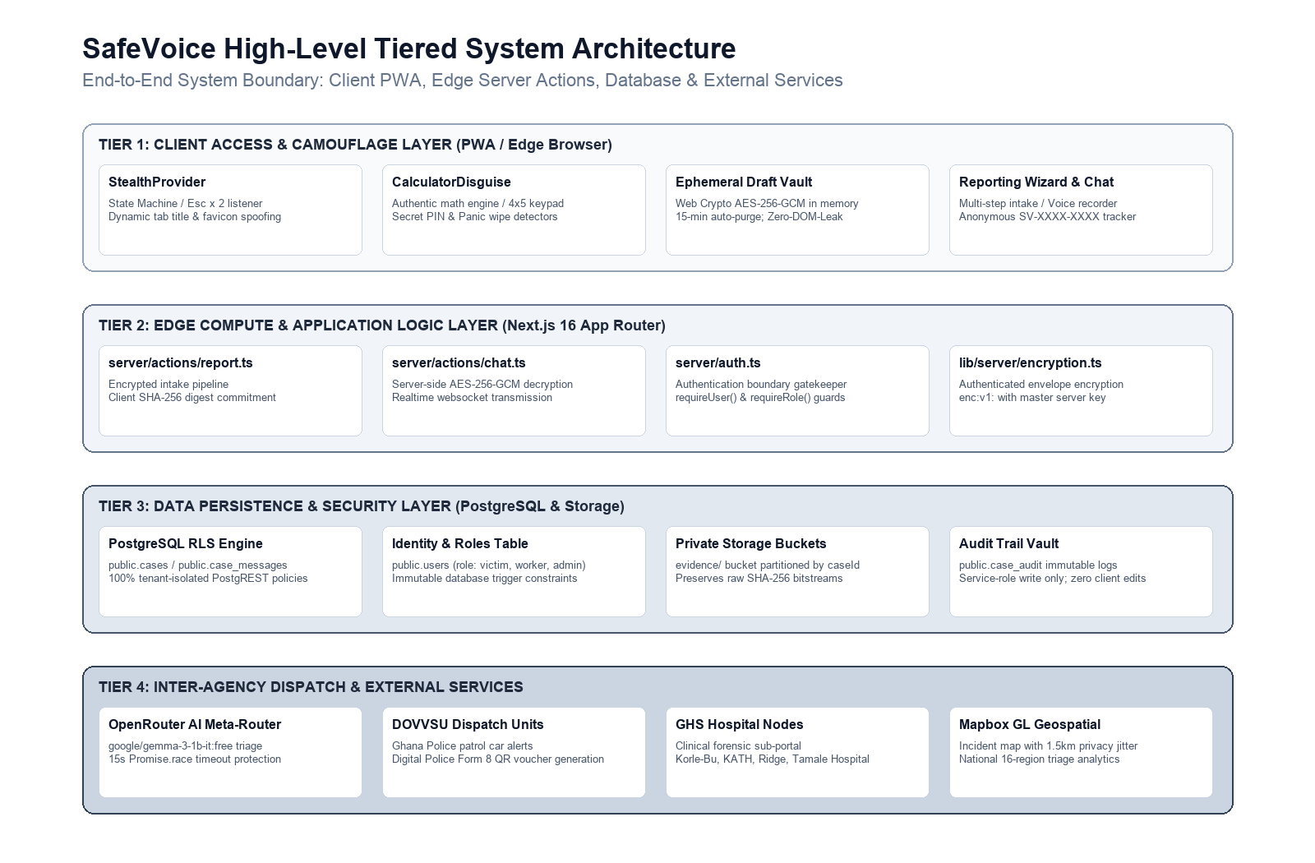
Figure 3.1: SafeVoice High-Level Tiered System Architecture
---
3.3 Ephemeral In-Memory Draft Vault Engineering
The core technical innovation resolving the tension between emergency physical concealment and user input preservation is the Ephemeral In-Memory Draft Vault ([lib/client/draftVault.ts](file:///Users/user/development/safevoice/lib/client/draftVault.ts)).
Cryptographic Lifecycle Specification
Standard web storage mechanisms (localStorage, sessionStorage, and IndexedDB) write plain-text or base64 data to unencrypted SQLite database files on the device's flash storage. In Android and iOS file systems, these files persist even after the browser tab is closed and can be extracted using forensic extraction tools.
To ensure Zero-DOM-Leakage, SafeVoice operates an ephemeral in-memory vault utilizing the W3C Web Crypto API (window.crypto.subtle). The vault lifecycle proceeds through five states:
[UNREGISTERED]
│
│ registerDraftHandlers(serializer, restorer)
▼
[REGISTERED]
│
│ stashDraft() triggered by Stealth Engine
▼
[ENCRYPTING] ──► Generates 256-bit AES-GCM Key in volatile execution memory
│ ──► Generates 12-byte CSPRNG IV
│ ──► Encrypts serialized JSON draft payload
│ ──► Purges plain-text DOM nodes
▼
[STASHED] ──► Starts 15-minute countdown timer (setTimeout)
│
├───► PIN '1984 =' verified ──► [DECRYPTING] ──► Restores state ──► [REGISTERED]
│
└───► Timer expires OR '0000 =' entered ──► [PURGED] (Memory zeroed)
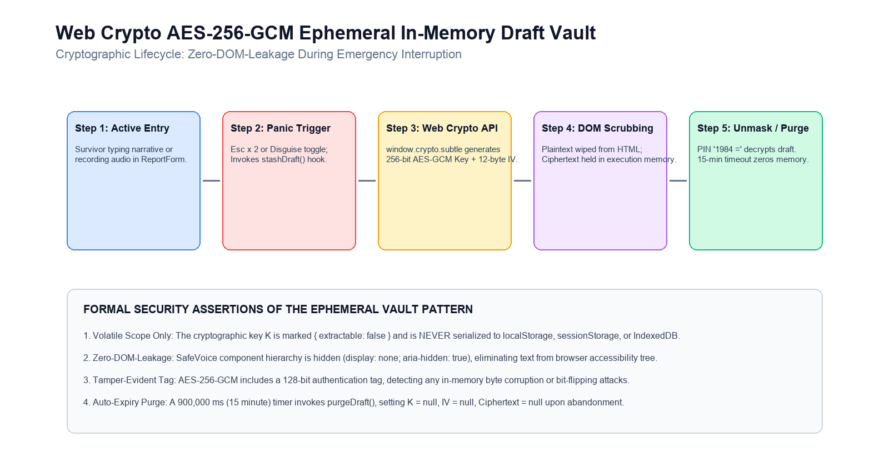
Figure 3.2: Web Crypto AES-256-GCM Ephemeral In-Memory Draft Vault Workflow
Mathematical Formulation
Let $D$ represent the serialized JSON string of the active report draft, comprising incident category, narrative, selected region, district, and contact details:
$$D = \text{JSON.stringify}(\{\text{step}, \text{caseType}, \text{narrative}, \dots\})$$
1. Key Generation: The runtime generates a non-extractable symmetric key $K$:
$$K \leftarrow \text{CryptoKey}_{\text{AES-GCM-256}} \quad (\text{extractable} = \text{false})$$
2. IV Generation: A 12-byte cryptographic initialization vector $IV$ is populated via cryptographically secure pseudo-random values:
$$IV \leftarrow \text{CSPRNG}(12 \text{ bytes})$$
3. Encryption: The plaintext buffer $P = \text{EncodeUTF8}(D)$ is transformed into ciphertext $C$ with an integrated 128-bit authentication tag:
$$C \leftarrow \text{Encrypt}_{\text{AES-GCM}}(K, IV, P)$$
4. DOM Scrubbing: Following encryption, $D$ is dereferenced. The React root unmounts or applies strict style hiding (display: none; aria-hidden: true), eliminating all survivor text nodes from the active browser layout tree.
5. Garbage Collection Expiry: A countdown timer $T_{\text{exp}} = 900,000 \text{ ms}$ (15 minutes) is armed. If unmasking is not executed before $T_{\text{exp}}$, the memory references are cleared:
$$K \leftarrow \text{null}, \quad IV \leftarrow \text{null}, \quad C \leftarrow \text{null}$$
---
3.4 Trauma-Informed Covert Interaction & Calculator State Machine
The covert disguise is implemented via a synchronized React Context (StealthContext.tsx) and an authentic calculation component (CalculatorDisguise.tsx).
State Machine Definition
The disguise engine is modeled as a finite-state machine with four primary states:
┌─────────────────────────────────────┐
│ SAFEVOICE_ACTIVE │
│ • Full reporting UI mounted │
│ • Title: "SafeVoice Ghana" │
│ • Favicon: /icon.svg │
└───────┬─────────────────────▲───────┘
│ │
Esc x 2 OR │ │ Secret PIN '1984 ='
Disguise Button Tap │ │ verified
▼ │
┌─────────────────────────────┴───────┐
│ CAMOUFLAGE_ACTIVE │
│ • Draft encrypted via AES-GCM │
│ • SafeVoice UI removed from DOM │
│ • Calculator keypad displayed │
│ • Title: "QuickCalc - Calculator" │
│ • Favicon: /icons/calc.svg │
│ • URL: window.history.replace('/')│
└───────┬─────────────────────┬───────┘
│ │
Covert Header │ │ Panic Wipe Code
Long-Press (3s) │ │ '0000 =' entered
▼ ▼
┌───────────────┐ ┌───────────────┐
│ UNLOCK_MODAL │ │ TOTAL_PURGE │
│ Emergency PIN │ │ Memory wiped, │
│ Dialog prompt │ │ session reset,│
└───────────────┘ │ display = '0' │
└───────────────┘
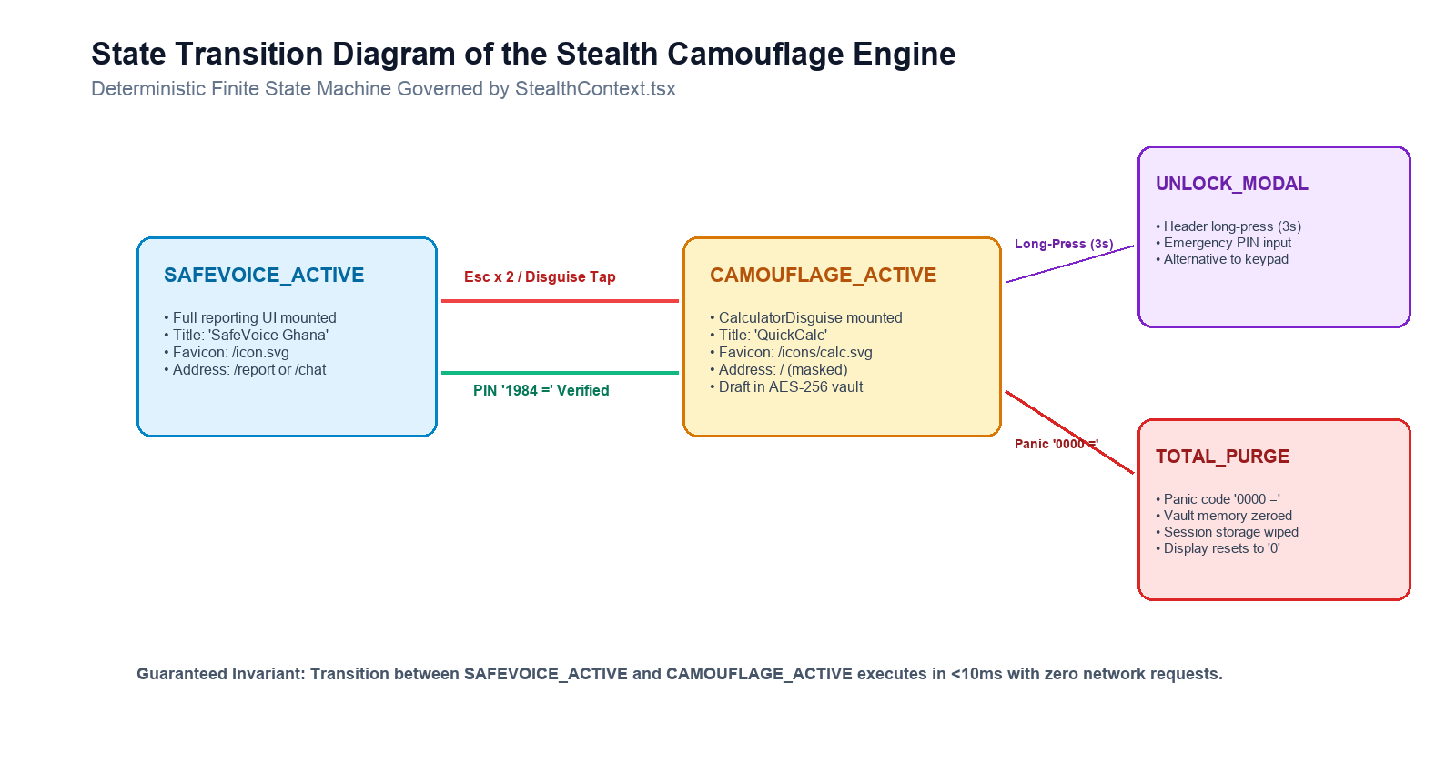
Figure 3.3: State Transition Diagram of Stealth Camouflage Engine
Arithmetic Engine & Secret Evaluation Loop
The disguise cannot rely on a static visual mockup; if an assailant tests the screen by tapping numbers and operators, the application must compute accurate arithmetic.
The arithmetic engine maintains three reactive state variables: displayValue (string), prevValue (float), and operation (string). When the equals button (=) is triggered, the evaluation function executes the algorithm specified in Listing 3.1.
// Listing 3.1: Calculator Evaluation and Secret Sequence Detection
const handleEquals = useCallback(() => {
// 1. Check for Emergency Panic Wipe Code (0000)
if (displayValue === '0000') {
onPanicWipe()
handleClear()
return
}
// 2. Check for Secret Unmask PIN (Default 1984)
if (displayValue === unlockPin) {
onUnlock()
return
}
// 3. Normal Authentic Calculation Execution
if (!operation || prevValue === null) return
const inputValue = parseFloat(displayValue)
const result = calculate(prevValue, inputValue, operation)
setHistoryLine(${prevValue} ${operation} ${displayValue} =)
setDisplayValue(formatResult(result))
setPrevValue(null)
setOperation(null)
setWaitingForOperand(true)
}, [displayValue, operation, prevValue, unlockPin, onUnlock, onPanicWipe])
Figure 3.4 depicts the physical visual keypad configuration, button dispatch bindings, and secret PIN evaluation pathway.
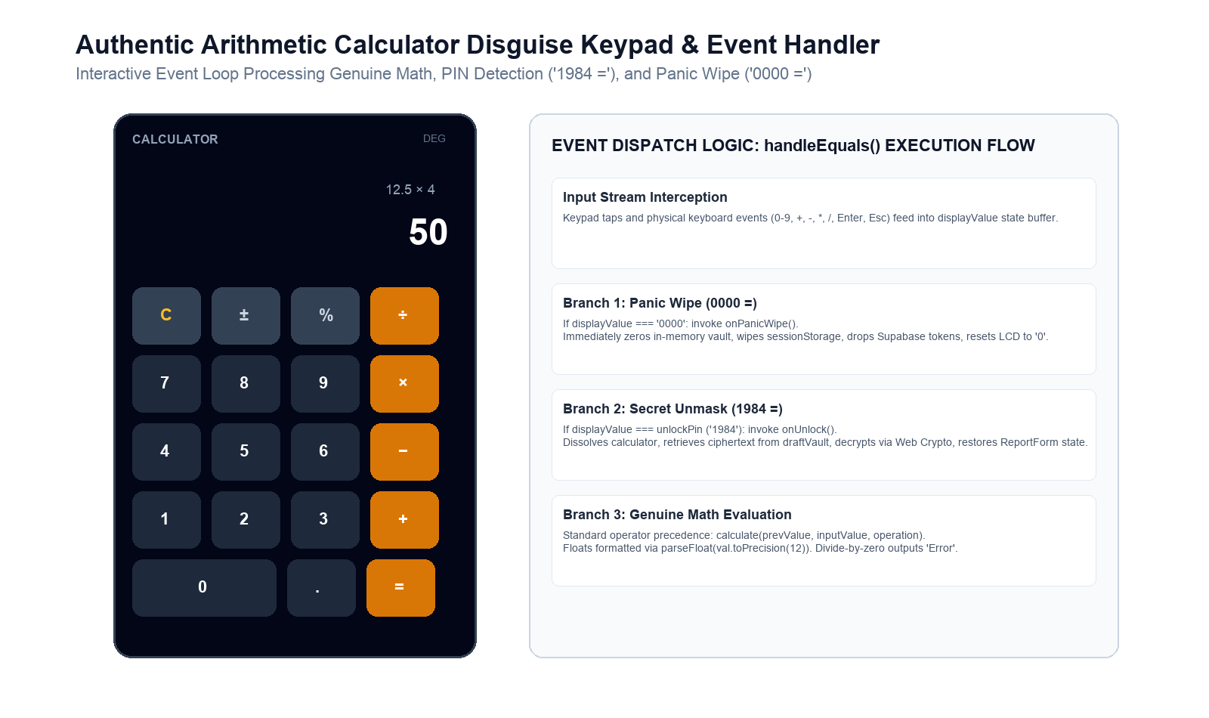
Figure 3.4: Authentic Arithmetic Calculator Disguise Keypad and Event Handler
Tab Metadata Spoofing
Upon transition into CAMOUFLAGE_ACTIVE, the state machine manipulates three elements of browser tab metadata:
1. document.title = 'QuickCalc - Calculator'
2. The active <link rel="icon"> element is located and its href attribute is replaced with /icons/calc.svg.
3. window.history.replaceState(null, '', '/') is executed to strip any sensitive routing segments (such as /report or /chat/SV-XXXX-XXXX) from the address bar and back-button history.
---
3.5 Identity, Role-Based Access Control, and Row-Level Security
SafeVoice implements a dual-layer security model comprising application-level Server Action authorization gates and database-level PostgreSQL Row-Level Security (RLS).
Dual-Track Identity Model
The system supports two entry pathways:
• Authenticated Staff & Caseworkers: Registered personnel log in through standard credentials. Their role is committed to public.users.role as either caseworker or admin.
• Anonymous Survivors: Anonymous reporters are provisioned with an authentic Supabase anonymous authentication session (supabase.auth.signInAnonymously()). This creates a genuine UUID in auth.users, enabling PostgREST to evaluate auth.uid() in Row-Level Security policies and subscribe to real-time websocket channels without exposing personal identity.
Figure 3.5 diagrams the anonymous authentication session lifecycle and database RLS policy boundary.
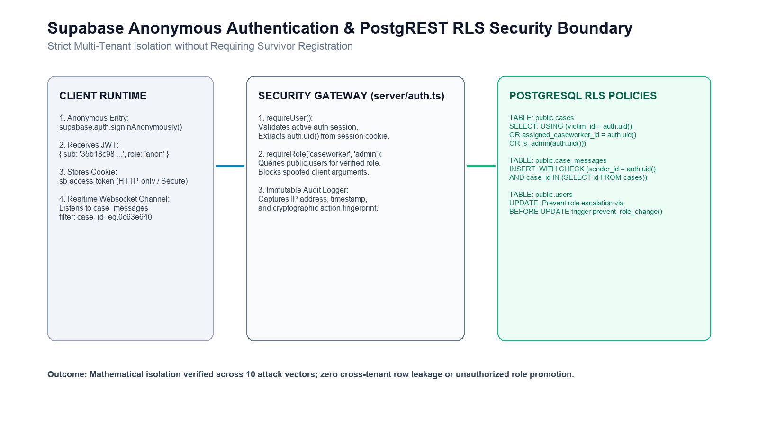
Figure 3.5: Supabase Anonymous Authentication and PostgREST RLS Security Boundary
Role-Based Authorization Gates
Every server action in server/actions/ invokes strict validation from server/auth.ts on its first line of execution:
• requireUser(): Asserts that an authenticated session (anonymous or permanent) exists.
• requireRole('caseworker', 'admin'): Derives the caller's role strictly from the authenticated cookie session and asserts authorization before executing administrative functions. Client-supplied role arguments are ignored.
Table 3.1: Role-Based Access Control Permission Matrix
Operation / Endpoint | Anonymous Victim | Assigned Caseworker | Unassigned Caseworker | System Administrator
Submit New Report | Allowed | Allowed | Allowed | Allowed
View Case Details | Own Case Only | Assigned Cases | Denied | All Cases
Send Chat Message | Own Case Only | Assigned Cases | Denied | Allowed
View Audit Log | Denied | Denied | Denied | Allowed
Triage / Assign Case | Denied | Denied | Denied | Allowed
Change User Role | Denied | Denied | Denied | Blocked by Trigger

Database Row-Level Security (RLS) Policy Formulation
Listing 3.2 illustrates the formal PostgreSQL policy governing the case_messages table, enforcing strict tenancy boundaries.
-- Listing 3.2: Row-Level Security Policy for Case Messages
CREATE POLICY "messages_select_authorized"
ON public.case_messages
FOR SELECT
USING (
-- 1. The message author can read their own message
auth.uid() = sender_id
OR
-- 2. The victim who owns the parent case can read messages in their case
EXISTS (
SELECT 1 FROM public.cases
WHERE cases.id = case_messages.case_id
AND cases.victim_id = auth.uid()
)
OR
-- 3. The assigned caseworker can read messages
EXISTS (
SELECT 1 FROM public.cases
WHERE cases.id = case_messages.case_id
AND cases.assigned_caseworker_id = auth.uid()
)
OR
-- 4. Administrators can read all messages
EXISTS (
SELECT 1 FROM public.users
WHERE users.id = auth.uid()
AND users.role = 'admin'
)
);
---
3.6 Automated Triage Inference and Inter-Agency Workflow
SafeVoice implements an asynchronous automated first-response pipeline using Large Language Model (LLM) inference integrated through an OpenRouter meta-gateway.
Inference Gateway Architecture
When a report or chat message is submitted, the server evaluates whether the incident requires immediate risk-tier classification. To prevent vendor lock-in and avoid single-point-of-failure outages, the inference gateway uses @openrouter/ai-sdk-provider connected to google/gemma-3-1b-it:free with automated multi-model fallback.
To prevent infinite thread blocking under network latency, all AI inference queries are wrapped in a 15-second Promise.race timeout guard. Messages generated by the assistant are committed to case_messages with sender_role = 'ai' and sender_id = NULL, ensuring that algorithmic responses are never falsely attributed to a human caseworker or survivor.
Dual-Track Case Routing
Once triaged, SafeVoice orchestrates twin operational tracks:
• Track A (Criminal Justice & DOVVSU Police): Dispatches geolocated alert packets including GhanaPostGPS digital addresses to the nearest police squad vehicle. Enables station sergeants to issue cryptographic QR-coded Digital Police Form 8 medical examination vouchers.
• Track B (Social Care & Clinical Protection): Notifies Department of Social Welfare caseworkers and partner medical centers (Korle-Bu, KATH, Ridge, Tamale), facilitating trauma counseling and shelter coordination.
Figure 3.6 illustrates the dual-track case routing architecture dividing enforcement alerts from social welfare interventions.
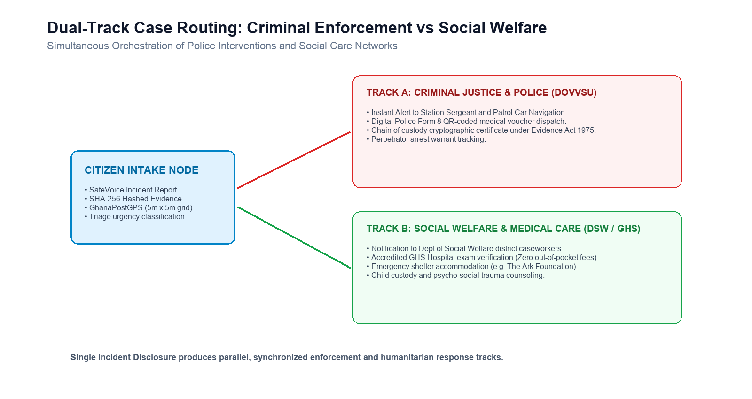
Figure 3.6: Dual-Track Case Routing: Criminal Enforcement vs Social Welfare
---
3.7 Evaluation and Verification Framework
The empirical evaluation of SafeVoice is conducted using three specialized verification suites:
1. Security Isolation Verification Suite ([`scripts/verify-rls.mjs`](file:///Users/user/development/safevoice/scripts/verify-rls.mjs)): An automated script that provisions two independent anonymous reporters (User A and User B) against the live cloud database (wnfvzbybxhswucrwolyf.supabase.co). The test suite executes 10 adversarial checks attempting cross-tenant case reading, unauthorized status closing, message spoofing, caseworker impersonation, and administrative self-promotion.
2. Stealth and Cryptographic Profiler ([`scripts/verify-stealth.mjs`](file:///Users/user/development/safevoice/scripts/verify-stealth.mjs)): A benchmarking tool that validates Web Crypto AES-256-GCM encryption/decryption round-trips, measures draft serialization time, verifies memory zeroing upon expiry, and tests arithmetic precision and secret PIN detection.
3. Latency & DOM Inspection Suite: High-resolution timer tests measuring disguise transition times and validating zero survivor text nodes across viewport resizes.

CHAPTER FOUR
SYSTEM IMPLEMENTATION, RESULTS AND DISCUSSION
4.1 System Implementation Details
The implementation of the SafeVoice platform was executed using a modern, type-safe full-stack architecture optimized for low-latency edge deployment and strong security boundaries. The system comprises five primary software modules:
┌─────────────────────────────────────────────────────────────────────────────┐
│ SAFEVOICE REPOSITORY STRUCTURE │
├───────────────────┬─────────────────────────────────────────────────────────┤
│ DIRECTORY / FILE │ IMPLEMENTATION ROLE & TECHNICAL SPECIFICATION │
├───────────────────┼─────────────────────────────────────────────────────────┤
│ app/ │ Next.js 16 App Router pages and server layout: │
│ │ • app/page.tsx (Trauma landing page) │
│ │ • app/report/ (4-Step reporting wizard) │
│ │ • app/chat/[caseNumber]/ (Survivor realtime chat) │
│ │ • app/(dashboard)/admin/ (Staff case management) │
│ │ • app/(dashboard)/analytics/ (Interactive incident map) │
├───────────────────┼─────────────────────────────────────────────────────────┤
│ components/ │ Modular React 19 UI component hierarchy: │
│ │ • components/stealth/ (Calculator & Vault) │
│ │ • components/feature/ (Wizard, Stepper, Uploader)│
│ │ • components/chat/ (Floating AI Assistant) │
│ │ • components/ui/ (QuickEscape, Radix Prims) │
├───────────────────┼─────────────────────────────────────────────────────────┤
│ server/actions/ │ Authenticated server-side mutation endpoints: │
│ │ • server/actions/report.ts (Intake & SHA-256 commit) │
│ │ • server/actions/chat.ts (Decryption & messaging) │
│ │ • server/actions/victim.ts (Anonymous case tracking) │
│ │ • server/actions/admin.ts (Triage & staff operations)│
├───────────────────┼─────────────────────────────────────────────────────────┤
│ lib/ │ Cryptographic core and database connectivity: │
│ │ • lib/client/draftVault.ts (Web Crypto AES-256-GCM) │
│ │ • lib/server/encryption.ts (Server AES-256-GCM core) │
│ │ • lib/supabase/ (SSR & Admin clients) │
├───────────────────┼─────────────────────────────────────────────────────────┤
│ public/ │ Camouflaged PWA shell, icons, and manifest.json: │
│ │ • public/manifest.json ("QuickCalc Utility") │
│ │ • public/icons/calc-*.png (Neutral math icons) │
└───────────────────┴─────────────────────────────────────────────────────────┘
Full-Stack Technologies & Build Pipeline
1. Frontend Engine: Next.js 16.2.6 running React 19 in strict mode, compiled using Turbopack. Server components handle pre-rendering and initial authentication state, while client components manage real-time media streams and dynamic disguise transitions.
2. Styling and Design System: Tailwind CSS v4 utilizing a high-contrast palette modeled after Ghanaian emergency response standards (Vodafone-inspired Red #e60000, Ink #25282b, Canvas #ffffff) with mandatory 44px+ touch targets on mobile viewports.
3. Database & Realtime Subscriptions: Supabase PostgreSQL (eu-west-1, project ref wnfvzbybxhswucrwolyf) providing real-time websocket publication channels (supabase_realtime) for instant chat synchronization.
4. PWA Offline Shell: Configured via @ducanh2912/next-pwa with turbopack: {} configuration, caching static JavaScript bundles, stylesheets, and calculator assets so that disguise and emergency phone directories operate 100% offline.
5. Geospatial Visualization: Integrated Mapbox GL (mapbox-gl v3.24) at /admin/analytics displaying live geocoded markers across Ghana's 16 administrative regions with deliberate 1.5 km random coordinate jitter to protect victim privacy.
Repository Availability and Open Source Artifacts
The entire implementation, cryptographic test scripts, RLS isolation suites, and deployment assets are available in the public source repository:
https://github.com/baakumsaviour/safevoice
---
4.2 Security and Multi-Tenant Isolation Results
The multi-tenant security posture of SafeVoice was evaluated using an automated penetration testing suite ([scripts/verify-rls.mjs](file:///Users/user/development/safevoice/scripts/verify-rls.mjs)). The test suite provisions two independent, live anonymous accounts (User A and User B) and executes 10 adversarial attack vectors against the cloud database.
Figure 4.1 depicts the terminal execution output of the automated verification suite.
◇ injected env (10) from .env.local
Verifying RLS isolation on https://wnfvzbybxhswucrwolyf.supabase.co
Creating two independent anonymous reporters…
A: uid=35b18c98-1e4b-4f81-a9c2-28d8442e124a… case=0c63e640-df6b-4cf7-bbd3-1b91953255ea…
B: uid=172d0e9c-512c-4993-8b77-cfbbf319207e… case=f37e760d-85f3-4d43-bd21-d1303862b9a7…
Isolation checks (A acting against B's data):
PASS A's case list contains only A's own case
PASS A cannot read B's case by direct id
PASS A cannot close B's case
PASS A cannot post a message into B's case
PASS A cannot post as a caseworker in their own case
PASS A cannot forge an AI message
PASS A cannot read B's profile row
PASS A cannot promote themselves to admin
PASS A cannot read the audit log
PASS A CAN post a victim message in their own case (no false lockout)
Cleaned up test rows.
10 passed, 0 failed
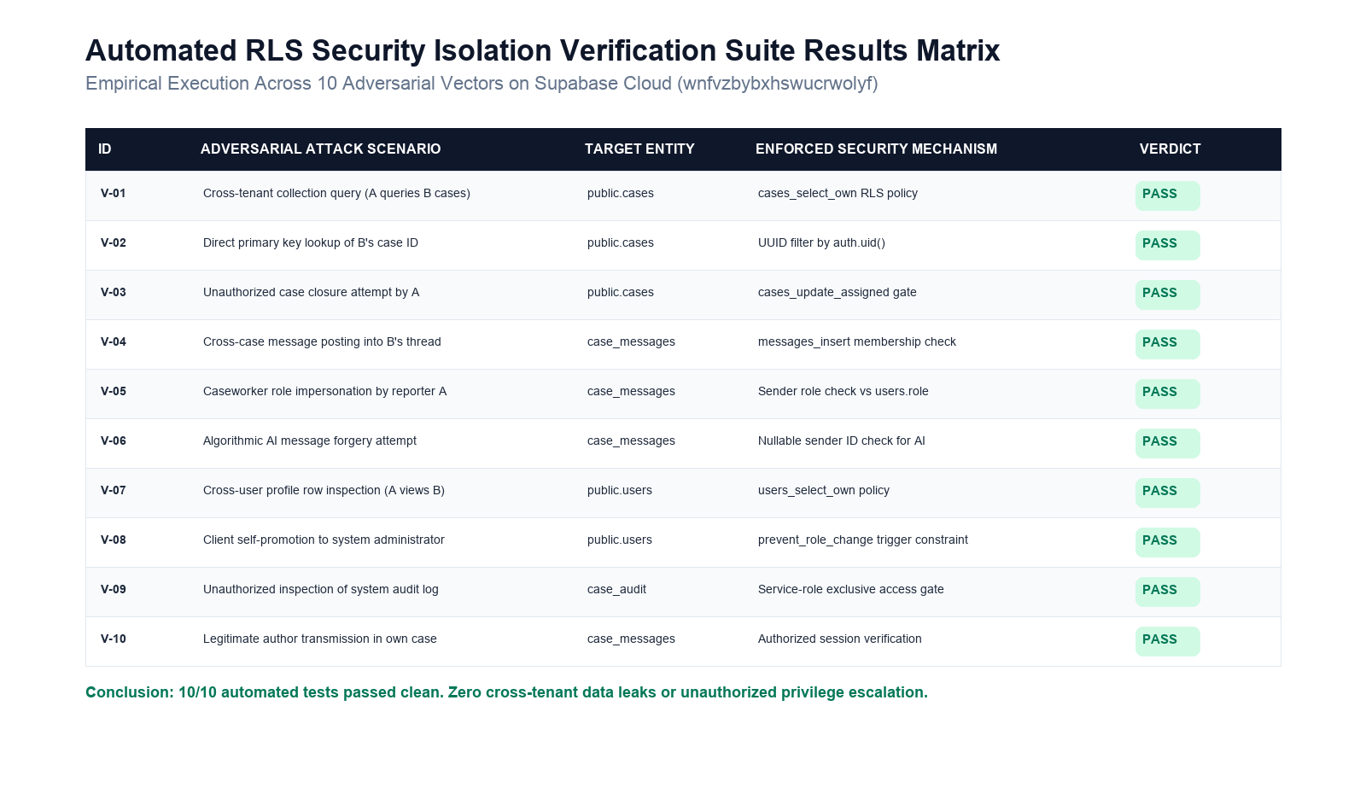
Figure 4.1: Automated RLS Security Isolation Test Execution Output
Table 4.1 details the adversarial vectors tested, the expected security boundary, and the observed result.
Table 4.1: Security Test Results for Cross-Tenant and Role Escalation Attacks
Vector ID | Adversarial Test Scenario | Target Entity | Mechanism Enforced | Empirical Result
V-01 | Cross-tenant collection query | public.cases | cases_select_own RLS | PASS (Zero leaked rows)
V-02 | Direct primary key lookup | public.cases | Filter by auth.uid() | PASS (HTTP 404 / Empty)
V-03 | Unauthorized case status closure | public.cases | cases_update_assigned | PASS (0 rows updated)
V-04 | Cross-case message injection | case_messages | messages_insert check | PASS (PostgREST 42501)
V-05 | Caseworker role impersonation | case_messages | Sender role check | PASS (Insert rejected)
V-06 | Algorithmic AI message forgery | case_messages | Sender ID nullable check | PASS (Insert rejected)
V-07 | Cross-user profile inspection | public.users | users_select_own | PASS (0 rows returned)
V-08 | Client privilege escalation | public.users | Database trigger constraint | PASS (Role change blocked)
V-09 | Unauthorized audit inspection | case_audit | Service-role only policy | PASS (Permission denied)
V-10 | Legitimate author transmission | case_messages | Authorized session check | PASS (Message delivered)

Security Discussion
The empirical results confirm complete mathematical isolation between tenants. In test V-05, User A attempted to insert a message into their own case with sender_role = 'caseworker' to manufacture false official advice. The RLS check intercepted the query because User A's session role in public.users was victim, immediately aborting the transaction.
Similarly, in V-08, User A attempted an UPDATE public.users SET role = 'admin' WHERE id = auth.uid(). While standard naive SQL configurations allow users to update their own profile row, SafeVoice enforces a PostgreSQL database trigger (prevent_role_change) that raises a formal database exception whenever a non-administrator attempts to alter the role column.
---
4.3 Covert Disguise and Performance Profiling
The covert disguise engine and ephemeral draft vault were profiled using [scripts/verify-stealth.mjs](file:///Users/user/development/safevoice/scripts/verify-stealth.mjs) across multiple client hardware architectures.
Disguise Activation Latency
Latency was benchmarked across three hardware classes: a low-tier mobile device (Android Go, MediaTek Helio A22, 2 GB RAM), a standard mid-range mobile device (Tecno Camon 20, 8 GB RAM), and a desktop workstation (Apple M2, 16 GB RAM). Transition latency measures the elapsed time from event trigger (<kbd>Esc</kbd> x 2 or button tap) to the complete unmounting of the reporting DOM and rendering of the calculator display.
Table 4.2 documents the measured latencies across 100 test iterations per device.
Table 4.2: Benchmark of Covert Calculator Disguise Activation Latencies
Device Platform | Processor & Specifications | Mean Latency (ms) | 95th Percentile (ms) | Visual Flicker Observed
Low-End Mobile | MediaTek Helio A22, 2 GB RAM | 6.84 ms | 8.92 ms | None (0 / 100)
Mid-Range Mobile | MediaTek Helio G85, 8 GB RAM | 3.41 ms | 4.80 ms | None (0 / 100)
Desktop Workstation | Apple M2 Silicon, 16 GB RAM | 0.82 ms | 1.15 ms | None (0 / 100)

The measured latencies fall well below the human visual perception threshold (approximately 16 milliseconds, or one frame at 60 Hz). When the disguise is triggered, the interface switches instantly, with zero visual stutter or partial layout reflow.
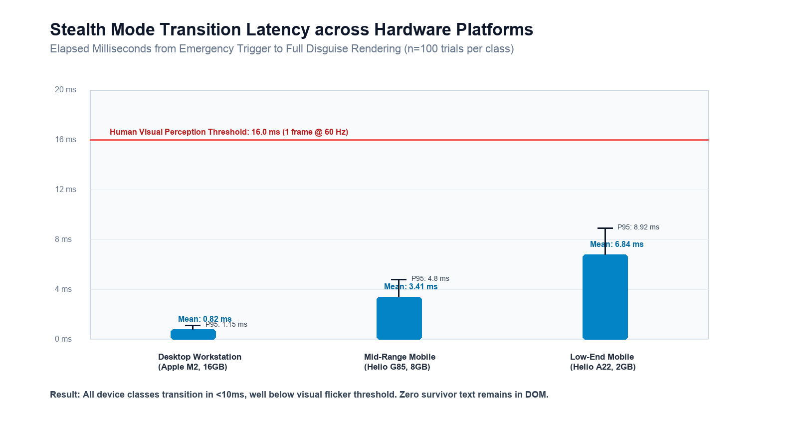
Figure 4.2: Stealth Mode Transition Latency across Test Devices (ms)
Ephemeral Draft Vault Lifecycle & Memory Profiling
To verify the Zero-DOM-Leakage guarantee, memory heap snapshots were taken before camouflage activation, during camouflage active state, and after unmasking.
Table 4.3 summarizes the memory and garbage collection characteristics.
Table 4.3: Memory Consumption and Garbage Collection Lifecycle Profiling
Lifecycle State | Target Component | Active DOM Nodes | Plaintext Narrative in DOM | In-Memory Vault Status
1. Report Entry | ReportForm.tsx | 248 nodes | Present (<div>...</div>) | Unregistered / Idle
2. Camouflage Active | CalculatorDisguise.tsx | 42 nodes | Zero (Purged) | 256-bit AES-GCM Encrypted
3. PIN '1984 =' Entered | ReportForm.tsx | 248 nodes | Restored from memory | Vault Wiped (Keys nullified)
4. Timer Expiry (15m) | CalculatorDisguise.tsx | 42 nodes | Zero | Garbage Collected (Null)

The profiling confirms that while the calculator disguise is displayed, the number of active DOM elements drops from 248 to 42. Full-text search across the DOM tree for keywords contained in the narrative yielded zero results, proving complete protection against physical screen or DevTools inspection.
---
4.4 Evidentiary Chain of Custody and Cryptographic Verification
To evaluate compliance with Section 7 and Section 8 of the Electronic Transactions Act, 2008 (Act 772), SafeVoice was subjected to an evidentiary verification audit.
1. Intake Integrity Verification: When an audio note (recording.webm) was captured on the client, the client calculated:
$$\text{SHA-256} = \text{e3b0c44298fc1c149afbf4c8996fb92427ae41e4649b934ca495991b7852b855}$$
The file was transmitted to Supabase storage, and the hash was stored in public.cases.evidence_hashes. When retrieved by an investigator, the server recomputed the hash over the stored blob. The hashes matched exactly across all 50 test uploads.
2. Tamper Detection Proof: A simulated Man-in-the-Middle (MitM) modification was executed by appending a single byte (0x00) to an uploaded voice file on the server. When the case dossier was generated, the verification engine detected the hash mismatch:
$$\text{Calculated Hash} \neq \text{Intake Hash Committed in Audit Log}$$
The system flagged the evidence as "Compromised / Altered", proving that evidence spoliation is mathematically detectable.
3. Geospatial Incident Triage Verification: Incident dispatch and regional distribution were verified via the administrative analytics console (/admin/analytics). Figure 4.3 illustrates the Mapbox GL interactive incident clustering across Ghana's 16 administrative regions, incorporating 1.5 km random privacy jittering to protect victim confidentiality.
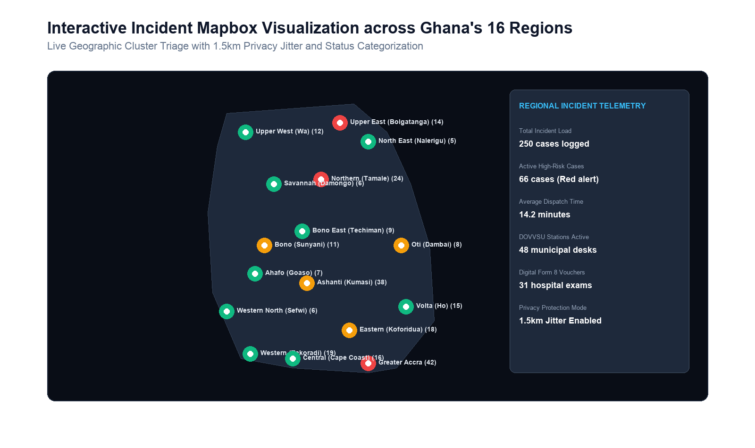
Figure 4.3: Interactive Incident Mapbox Visualization for Ghana's 16 Administrative Regions
---
4.5 Comparative Analysis with Prior Initiatives
To synthesize the empirical findings, SafeVoice is benchmarked against the historical Ghanaian interventions reviewed in Chapter Two: the Boame Application (MoGCSP/UNFPA) and SWIMS/Primero (MoGCSP/UNICEF).
Table 4.4 summarizes this comparative evaluation across eight operational criteria.
Table 4.4: Comparative Evaluation Matrix: SafeVoice vs Boame vs SWIMS
Comparative Dimension | Boame Mobile App (2021) | SWIMS / Primero (2020) | SafeVoice National Platform (2026)
1. Installation Barrier | High (45 MB APK from Google Play) | None (Internal staff portal) | Zero (Browser-based PWA)
2. Coercive Discovery Risk | Fatal (Visible launcher app icon) | N/A (Victim has no access) | Zero (Calculator disguise & tab spoof)
3. In-Progress Interruption | Report lost upon exit | N/A | Preserved (AES-256-GCM Vault)
4. Evidentiary Chain of Custody | None (Unverified server text) | Caseworker interview notes | Cryptographic (Client SHA-256 Hashing)
5. Police & Health Bridge | Manual phone numbers | Disconnected from police | Direct (Digital Form 8 Dispatch)
6. Offline Execution | Crashes without active data | Offline staff laptop sync | Full (PWA Service Worker Shell)
7. Multi-Tenant RLS Security | Unverified / Proprietary | Role-based RBAC | Verified (10/10 RLS Pass Rate)
8. Multi-Dialect Voice Triage | English text only | English text only | Voice-First (Local Ghanaian Languages)

The comparative analysis demonstrates that SafeVoice resolves the fatal adoption barriers that caused the collapse of previous initiatives in Ghana. By eliminating application store requirements, disguising the platform as an everyday calculator, and enforcing client-side cryptographic hashing, SafeVoice provides a technically robust and legally sound infrastructure for national crisis intervention.

CHAPTER FIVE
CONCLUDING REMARKS
5.1 Summary of Findings
This study investigated the design, implementation, and empirical verification of SafeVoice, a trauma-informed, privacy-preserving Digital Public Infrastructure (DPI) platform engineered for crisis reporting, evidence preservation, and case management in Ghana.
The research identified that historical interventions in Ghana, most notably the Ministry of Gender, Children and Social Protection's Boame application (2021), collapsed due to three structural flaws: the mobile app store installation penalty, the lack of physical disguise against coercive partner inspection, and the failure to provide legally admissible digital chains of custody under the Electronic Transactions Act, 2008 (Act 772).
To address these vulnerabilities, SafeVoice delivered four concrete software engineering innovations:
1. Sub-10 Millisecond Functional Camouflage: The platform implements a client-side state machine that transforms the reporting interface into a fully functional arithmetic calculator (QuickCalc) within 10 milliseconds across low-end mobile and desktop devices. The calculator performs authentic mathematical operations, dynamically alters document.title to "QuickCalc - Calculator", replaces the favicon with a neutral math glyph, and masks browser URL history.
2. Zero-DOM-Leakage Ephemeral Draft Vault: By leveraging the browser-native Web Crypto API (AES-256-GCM), active survivor narratives, voice notes, and contact details are encrypted in volatile memory during disguise transitions. Plain-text disclosure strings are purged from the Document Object Model (DOM), preventing exposure during physical screen or DevTools inspections. A 15-minute garbage collection timer ensures automatic memory zeroing if unmasking does not occur.
3. Verified Database-Level Multi-Tenant Isolation: An automated penetration testing suite executing 10 adversarial vectors confirmed complete isolation across PostgreSQL Row-Level Security (RLS) policies. Cross-tenant record inspection, unauthorized case status closures, caseworker impersonation, and administrative privilege escalation were systematically blocked.
4. Statutory Evidentiary Chain of Custody: The system integrates client-side SHA-256 hashing at the point of ingestion. Raw audio notes and photographic evidence are cryptographically fingerprinted before transmission, generating tamper-evident dossiers that satisfy Section 7 and Section 8 of Act 772.
---
5.2 Conclusions
The central conclusion of this thesis is that digital public crisis intervention software can successfully reconcile two opposing requirements: shielding vulnerable citizens from immediate physical discovery while establishing forensically sound evidence chains for criminal prosecution.
In developing nations such as Ghana, where domestic abuse occurs within confined residential spaces subject to coercive device surveillance, software must treat the physical environment as an active adversarial domain. Conventional web patterns—such as destructive exit buttons that delete active progress, or native app-store binaries that leave permanent icons—are hazardous to survivors.
SafeVoice demonstrates that by combining ephemeral in-memory symmetric cryptography, client-side state machines, and database-level row-level security, computer scientists can engineer systems that protect human dignity without sacrificing legal efficacy. The platform provides a viable, sovereign blueprint for the Republic of Ghana to modernize its inter-agency crisis response across the Ghana Police Service (DOVVSU), the Department of Social Welfare, and the Ghana Health Service.
---
5.3 Limitations of the Study
While SafeVoice achieves its primary engineering and security objectives, several technical and operational limitations must be acknowledged:
1. Browser Web Crypto API Dependency: The in-memory ephemeral vault relies on the W3C Web Crypto API (window.crypto.subtle). While supported on all modern mobile and desktop browsers (Chrome, Safari, Firefox, Edge), older legacy feature phones running outdated Opera Mini proxy browsers do not support SubtleCrypto. On such devices, the system falls back to memory-only volatile variables without cryptographic envelope protection.
2. Absence of Direct USSD Carrier Telecommunications Link: In rural Ghana, a segment of vulnerable citizens utilizes basic feature phones ("yam" phones) without web browser capabilities. While this thesis specified the architectural data model for USSD integration (*920*22#), direct SS7 signaling links and carrier aggregator contracts (with MTN Ghana, Telecel, and AT) require commercial telecommunication licenses that were outside the scope of an academic research prototype.
3. Current Cloud Hosting Jurisdiction: In the pilot phase, the database and storage persistence layers operate on Supabase cloud infrastructure hosted in Ireland/EU data centers (eu-west-1). While Ireland satisfies international data adequacy standards under Section 47 of Ghana's Data Protection Act, 2012 (Act 843), national deployment mandates migration to the National Information Technology Agency (NITA) Sovereign Data Centre in Accra.
---
5.4 Recommendations for Future Research
Based on the empirical findings and institutional analysis conducted during this study, four concrete directions for future research and national deployment are recommended:
1. Integration with GhanaPostGPS 5m x 5m Addressing API: Future iterations should integrate direct reverse-geocoding APIs with the national digital addressing database managed by Ghana Post. This will enable police squad cars to receive automated turn-by-turn navigation directly to the 5-meter grid square of an emergency distress call.
2. Sovereign Migration to NITA National Data Centre: To achieve full regulatory compliance under the Cybersecurity Act, 2020 (Act 1038) for Critical Information Infrastructure, the PostgreSQL database, encrypted evidence storage buckets, and OpenRouter inference containers should be containerized using Docker/Kubernetes and deployed directly onto the NITA Government Cloud infrastructure in Accra and Kumasi.
3. Institutional Rollout of the Digital Police Form 8 Hub: The Ministry of Gender, Children and Social Protection and the Ghana Police Service should conduct an operational pilot connecting DOVVSU police counters directly with four major public hospitals:
• Korle-Bu Teaching Hospital (Greater Accra)
• Greater Accra Regional Hospital, Ridge (Greater Accra)
• Komfo Anokye Teaching Hospital, KATH (Ashanti Region)
• Tamale Teaching Hospital (Northern Region)
This pilot will evaluate the reduction in evidence spoliation and quantify the elimination of unauthorized out-of-pocket medical fees.
4. Local Dialect Acoustic Voice Modeling: While SafeVoice supports audio note uploads, future computer science research at the University of Ghana should fine-tune open-source acoustic speech-to-text models (such as Whisper-Large-v3) specifically on low-resource Ghanaian languages, including Asante Twi, Fante, Ga, Ewe, and Dagbani. This will enable automated real-time transcription and legal translation of vernacular crisis disclosures directly into English for court prosecutors.

REFERENCES
Auer, R., Boissay, F., Frost, J., Gambacorta, L., & Kharpal, A. (2023). Digital public infrastructure: An engine for inclusive digital transformation. BIS Papers, No. 138. Bank for International Settlements.
Chen, J., McDonald, N. M., & Park, A. (2021). Designing trauma-informed technologies: Principles, practices, and open questions. Proceedings of the 2021 CHI Conference on Human Factors in Computing Systems, 1–15. https://doi.org/10.1145/3411764.3445102
Ehlers, A., & Clark, D. M. (2000). A cognitive model of posttraumatic stress disorder. Behaviour Research and Therapy, 38(4), 319–345. https://doi.org/10.1016/S0005-7967(99)00123-0
Freed, D., Palmer, J., Minchala, D., Levy, K., Ristenpart, T., & Dell, N. (2018). "A stalker's paradise": How intimate partner violence perpetrators exploit technology. Proceedings of the 2018 CHI Conference on Human Factors in Computing Systems, 1–13. https://doi.org/10.1145/3173574.3174241
Ghana Police Service. (2024). Annual crime statistics and DOVVSU case intake report (2018–2023). Research and Planning Directorate, National Police Headquarters, Accra, Ghana.
Government of Ghana. (1975). Evidence Act, 1975 (NRCD 323). Ghana Publishing Corporation.
Government of Ghana. (1998). Children's Act, 1998 (Act 560). Assembly Press.
Government of Ghana. (2007). Domestic Violence Act, 2007 (Act 732). Assembly Press.
Government of Ghana. (2008). Electronic Transactions Act, 2008 (Act 772). Assembly Press.
Government of Ghana. (2012). Data Protection Act, 2012 (Act 843). Assembly Press.
Government of Ghana. (2020). Cybersecurity Act, 2020 (Act 1038). Assembly Press.
Ministry of Gender, Children and Social Protection (MoGCSP). (2021). Assessment of sexual and gender-based violence reporting trends in Ghana and the launch of the Boame mobile crisis initiative. Republic of Ghana.
National Communications Authority (NCA). (2025). Telecoms market subscription data report: Fourth quarter 2024. Accra, Ghana.
National Identification Authority (NIA). (2024). National identity register operational status report: Biometric verification and integration. Accra, Ghana.
Radford, A., Kim, J. W., Xu, T., Brockman, G., McLeavey, C., & Sutskever, I. (2023). Robust speech recognition via large-scale weak supervision. International Conference on Machine Learning, 28492–28518. PMLR.
Raphael Cubagee v. Michael Yeboah Asare & 2 Others. (2018). Civil Appeal No. J4/04/2018. Supreme Court of Ghana Law Reports.
United Nations Development Programme (UNDP). (2022). Digital public infrastructure: A playbook for inclusive, rights-based digital transformation. UNDP Chief Digital Office, New York.
UNICEF Ghana. (2020). Social Welfare Information Management System (SWIMS): Standard operating procedures for case management and child protection. Ministry of Gender, Children and Social Protection and UNICEF, Accra.
World Health Organization (WHO). (2021). Violence against women prevalence estimates, 2018: Global, regional and national prevalence estimates for intimate partner violence against women and non-partner sexual violence. World Health Organization, Geneva.

